ENVIRONMENT, OCCUPATIONAL HEALTH & PUBLIC HEALTH NUTRITION
ENVIRONMENT
Topic | Competency | Teaching-learning transaction
Drinking water | Collection and transport of water samples | Demonstration & hands on training in the community setting
Drinking water | Preparation of ORS (Packet and home made | Demonstration & hands on training in the community setting
Drinking water | Chlorination of water at domestic level | Exercise and demonstration
Entomology | Ability to prescribe effective use of insecticides in the community setting | Exercise and field area observation
Biomedical waste management | Disaggregating and use of colour coding in waste disposal | Case study with reference to Modassa, Gujarat. Visit to hospital casualty/wards for observation and waste disposal site
Biomedical waste management | Preparation of different strengths of bleaching powder solutions | Demonstration
Biomedical waste management | Counseling on infection control with a view to water and airborne diseases (sputum, stool disposal etc.) | Role play and case scenario
Entomology | Ability to prescribe effective use of insecticides in the community setting | Exercise and field area observation
OCCUPATIONAL HEALTH
Industry | Use and application of safety equipment in the industrial setting |  | Visit to a factory
Industry | **Ability to screen workers for occupational health issues |  | Attend GOPD of ESI Hospitals
Industry | Counseling on occupational health hazards |  | Role plays and case scenario
hospitals | Ability to practice universal safety precautions in the hospital setting for HIV |  | Visit to different departments in the hospital
hospitals | Pre-hospital management of occupational and environmental injuries and life threatening conditions |  | Use of dummies and video
Disaster | Ability to use triage concept in disaster situations |  | Video and exercies
PUBLIC HEALTH NUTRITION
Nutritional status | Measure, plot, interpret and counsel on appropriate feeding and food safety for under five children |  | Visit to AWC/VHND; Family study and follow up
Nutritional status | Assess for anemia , VAD and IDD and counsel/ advice on supplementation an dietary diversification; salt testing and administration of vitamin A solution |  | Visit to AWC/VHND
Diet | Diet planning /menu for normal physiological conditions and illnesses (diet related chronic diseases) |  | Exercise and practice in wards
IYCF | Assess and counsel for appropriate IYCF |  | Visit to AWC/VHND
- All visits are to be accompanied by exercises and check lists given to students
- 1 visit- Anganwadi centre: Growth monitoring, Nutrition counselling, Counselling for Mothers and Children, etc.
- 1 Visit- Factory for Occupational Health
- 1 Visit-Water Treatment Plant
- 1 Visit- Biomedical Waste Mangement

ENVIRONMENT

SECTION A

DRINKING WATER

COLLECTION AND TRANSPORT OF WATER SAMPLES

Criteria for Water Sample Submission to the SPHL

In support of a request from the general public:
  - Individuals may obtain a sample kit from the DHSS or LPHA and collect the water sample themselves and submit to the SPHL. This is known as an unofficial sample and will only be tested for bacteriological agents.
  - Do not test Department of Natural Resources regulated water supplies.
- In support of a routine or enforcement inspection of a regulated establishment:
- Samples must be properly collected and submitted by DHSS or LPHA staff.
- Samples must be properly transported and submitted with complete documentation.
- In support of a food-borne disease outbreak investigation:
- Investigation shall be coordinated by DHSS, Section for Disease Control and Environmental Epidemiology.
- Samples must be properly collected and submitted by DHSS or LPHA staff. Sample collection and submission shall be coordinated through the Regional Epidemiology Specialist.
- Samples must be properly transported and submitted with complete documentation.

Water Sampling Procedures (Bacteriological for potable/drinking water)
Only samples collected in bottles prepared by the SPHL and collected in accordance with the following steps will be accepted for analysis. DHSS or LPHA staff, or a private individual can collect a water sample for bacteriological analysis.
- The sample should be taken from a smooth-nosed cold-water tap, if possible. Avoid collecting samples from leaking taps that allow water to flow over the outside of the tap or from frost-proof hydrants or hot-cold mixing faucets, since it is not practical to sterilize these fixtures.
- Remove aeration devices and screens from faucet before sampling. Open the tap fully and let water run to waste for two (2) to three (3) minutes or until the service line has been thoroughly flushed.
- Chemically disinfect the tap by thoroughly rinsing both the inside and outside of the tap with a 100 ppm solution of sodium hypochlorite (NaOCL). This solution can be made by mixing ¼ ounce (1.5 teaspoons) of household bleach with one gallon of clean water. If tap cleanliness is questionable, provisions should be made to allow the solution to remain in contact with the tap for up to fifteen (15) minutes or to increase the strength of the solution to ensure adequate disinfection.
- Flush the tap for an additional two (2) or three (3) minutes then reduce to a gentle flow to permit filling the bottle without splashing.
- DO NOT RINSE THE SAMPLING BOTTLE and KEEP BOTTLE CLOSED UNTIL IT IS TO BE FILLED. The bottles contain a chlorine neutralizer that is present in liquid or crystalline form. They are sterile and ready for use when shipped. A loose cap does not affect sterility. Some bottles have a plastic seal, which must be removed for the lid before use.
- Grasp the cap along the top edge and remove. DO NOT TOUCH THE INSIDE OF THE CAP OR THE BOTTLE, AND DO NOT ATTEMPT TO CLEAN OR RINSE THE BOTTLE.
- Hold the bottle so that water entering it will not come in contact with your hands. Allow water to flow smoothly from the tap and fill the bottle to the 100 ml line (or fill to the black line present on some bottles). SAMPLE WILL NOT BE TESTED IF THERE IS LESS THAN ½ INCH AIR SPACE IN THE BOTTLE.
- Replace cap on bottle and tighten securely.

Shipment of Water Samples-Bacteriological

Samples shall only be collected on Monday, Tuesday or Wednesday except in an emergency.
  - Ship samples immediately after collection. This is important because samples should be in transit no more than 24 hours for best analytical results.
  - To ensure shortest shopping time, samples may be carried directly to the laboratory, shipped by state courier or commercial carrier service (use first class postage). Samples received in the laboratory more than 30 hours after collection will not be tested.
  - Samples should not be en route to the laboratory over a weekend or state holiday.

Water Sampling Procedures (Chemical for potable/drinking water)
Only samples collected in bottles prepared by the SPHL and collected in accordance with the following steps will be accepted for analysis. Only DHSS or LPHA staff can collect a water sample for chemical analysis.

New Well Series:
- Must use a one (1) liter cubitainer.
- The sample should be taken as close to the wellhead as possible.
- It is not required to let the water run or to disinfect the tap prior to taking the sample.
- DO NOT RINSE THE SAMPLING CUBITAINER and KEEP CUBITAINER CLOSED UNTIL IT IS TO BE FILLED.
- The cubitainer comes collapsed for shipping purposes. When inflating the cubitainer take care not to contaminate the inside of the container. Remove the lid and allow the water to flow slowly into the cubitainer. This will typically cause the container to self-inflate. If not, gently pull on the outside corner of the cubitainer to inflate. DO NOT BLOW INTO THE CUBITAINER TO INFLATE.
- Replace cap on cubitainer and tighten securely.

Nitrates: nitrate levels of ten (10) ppm shall not be used for drinking water.
- Must use a one (1) liter cubitainer.
- The sample can be taken anywhere along the distribution system.
- It is not required to let the water run or to disinfect the tap prior to taking the sample.
- DO NOT RINSE THE SAMPLING CUBITAINER and KEEP CUBITAINER CLOSED UNTIL IT IS TO BE FILLED.
- The cubitainer comes collapsed for shipping purposes. When inflating the cubitainer take care not to contaminate the inside of the container. Remove the lid and allow the water to flow slowly into the cubitainer. This will typically cause the container to self-inflate. If not, gently pull on the outside corner of the cubitainer to inflate. DO NOT BLOW INTO THE CUBITAINER TO INFLATE.
- Replace cap on cubitainer and tighten securely.

Shipment of Water Samples-Chemical

Samples can be collected any day of the week.
  - It is highly recommended to ship samples the same day of collection.
  - To ensure shortest shopping time, samples may be carried directly to the laboratory, shipped by state courier or commercial carrier service (use first class postage).

Bacteriological Analysis For Drinking Water

Coliform Bacteria: Coliforms are a group of bacteria found in the intestines of humans and other animals. Coliforms also occur naturally in the soil, on vegetation and in surface waters (lakes and streams). Most members of the coliform group do not cause disease. When found in drinking water, coliform bacteria indicate that contamination of the water has occurred, and that other disease causing bacteria could also get into the water supply.

E.coli: Escherichia coli (E. Coli) is a member of the coliform group of bacteria and is found only in the intestines of warm-blooded animals, including humans. When found in drinking water, E. coli indicates the water has been contaminated with human or animal wastes. Possible sources of contamination include leaking septic systems, surface water leaking into the supply and runoff from agricultural lots.

Explanation of Laboratory Report

Total Coliform and E. coli ABSENT: Coliform and E. coli bacteria were not detected in the sample tested. Sample is considered SATISFACTORY for drinking water purposes.

Total Coliform PRESENT: Coliform bacteria were detected in the sample tested. Sample is considered UNSATISFACTORY for drinking water purposes. If coliform bacteria are present in the sample, it will then be analyzed for the presence of E. coli.

E. coli PRESENT: E. coli bacteria were also detected in the sample tested. Sample is considered UNSATISFACTORY for drinking water purposes. Presence of E. coli bacteria indicates fecal contamination of the water supply has occurred, therefore an increased risk to the health of those consuming the water may exist.

UNSATISFACTORY FOR TESTING: Each sample is considered on its own merits. Examples of samples that have to be rejected for analysis include:
- Samples that have been collected in improper containers;
- Samples that are received more than 30 hours after collection;
- Samples with detectable chlorine present;
- Sample quantity not sufficient;
- Sample bottle overfilled;
- Inaccurate or incomplete information on the accompanying sample form, or
- Sample collected from a source other than a drinking water supply.
If standard methodology for collection and maintaining sample integrity is not followed as explained on the sample collection instruction sheet the sample may be deemed unacceptable for testing.

If Water Sample Reported “UNSATISFACTORY FOR DRINKING”
The water supply should not be used for drinking or cooking purposes. Although unsatisfactory results do not conclusively confirm the presence of pathogenic (disease-causing) organisms in the water, this result should alert you to such a possibility.

Private Individual
If asked by the individual, the following information should be relayed:
- To continue to use the water for drinking or cooking purposes, disinfect by:
  - Boiling vigorously for one (1) full minute before use; or
  - Chemically disinfect the water by adding two (2) drops (double the amount for cloudy or colored water) of regular household chlorine bleach (5.25 percent chlorine) to each quart of water used. Mix thoroughly and allow to stand for 30 minutes before use.
    - Check and correct any above-ground structural defect of the water supply that would allow surface water to enter the supply, such as defective seals, covers, surface drainage toward the well, etc.
    - Disinfect the water supply and distribution system by:
  - Introducing the prescribed amount of disinfectant (chlorine) into the well.
  - Opening all faucets in the distribution system and letting the water run until a distinct chlorine odor is noted. Flush toilets also.
  - Turning off all faucets and allowing the water to stand in the system for at least four (4) hours. Preferably overnight.
  - Opening the faucets and allowing the water to run until a suitable level of chlorine is reached (approximately 0.5 ppm) or until no chlorine odor is present.

In approximately five (5) to seven (7) days, resample the supply and submit it to the SPHL. An initial “Unsatisfactory” result should be followed up with two (2) consecutive “Satisfactory” samples taken on a weekly basis after disinfection of the water supply.

Regulated Establishments
See Section 4.0 Private Water, Subsection 4.2 Requirements for Operating Regulated Establishments-Boil Orders.

Inaccurate Results
- Inaccurate results may arise from an improper sampling point. A mixing-type faucet with an aerator, drain-back yard hydrant or frost-proof faucet may produce a questionable result due to contamination introduced at the point of collection. The sampling point should be a single cold-water faucet with the shutoff valve near the spout opening.
Transit time greater than 30 hours from the time of collection may also affect results. Samples should be carried directly to the laboratory, shipped by state courier or commercial carrier service (use first class postage) to assure fast delivery.

EXERCISE:
- Plan visit to nearest water treatment plant and laboratory and assist the field worker in collection and transport of the drinking water and transport to the laboratory.
- Gain knowledge from field worker that in
- How he check which water source to be tested
- What are their contingency plans if kit is not available?

ORAL REHYDRATION SOLUTIONS: MADE AT HOME
The most effective, least expensive way to manage diarrhoeal dehydration
To prevent too much liquid being lost from the child's body, an effective oral rehydration solution can be made using ingredients found in almost every household. One of these drinks should be given to the child every time a watery stool is passed.
Ideally these drinks (preferably those that have been boiled) should contain:
- starches and/or sugars as a source of glucose and energy,
- some sodium and
- Preferably some potassium.
The following traditional remedies make highly effective oral rehydration solutions and are suitable drinks to prevent a child from losing too much liquid during diarrhoea:
- Breast milk
- Gruels (diluted mixtures of cooked cereals and water)
- Carrot Soup
- Rice water - congee
A very suitable and effective simple solution for rehydrating a child can also be made by using salt and sugar, if these ingredients are available.
If possible, add 1/2 cup orange juice or some mashed banana to improve the taste and provide some potassium.
Molasses and other forms of raw sugar can be used instead of white sugar, and these contain more potassium than white sugar.
If none of these drinks is available, other alternatives are:
- Fresh fruit juice
- Weak tea
- Green coconut water
If nothing else is available, give
- Water from the cleanest possible source
(if possible brought to the boil and then cooled).
The "simple solution"
Home made ORS recipe
Preparing a 1 (one) liter oral rehydration solution [ORS] using Salt, Sugar and Water at Home
Mix an oral rehydration solution using one of the following recipes; depending on ingredients and container availability:
Ingredients:
- one level teaspoon of salt
- eight level teaspoons of sugar
- One litre of clean drinking or boiled water and then cooled
5 cupfuls (each cup about 200 ml.)
Preparation Method:
- Stir the mixture till the salt and sugar dissolve.

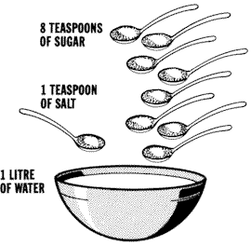
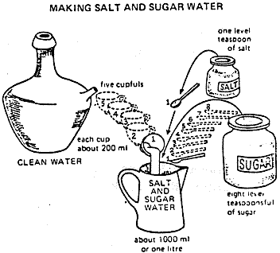

An efficient and effective homemade remedy to be used when watery diarrhea strikes and is a good substitute for oral rehydration salts
Ingredients:
- 1/2 to 1 cup precooked baby rice cereal or 1½ tablespoons of granulated sugar
- 2 cups of water
- 1/2 tsp. salt
Instructions:
Mix well the rice cereal (or sugar), water, and salt together until the mixture thickens but is not too thick to drink.
Give the mixture often by spoon and offer the child as much as he or she will accept (every minute if the child will take it).
Continue giving the mixture with the goal of replacing the fluid lost: one cup lost, give a cup. Even if the child is vomiting, the mixture can be offered in small amounts (2-1 tsp.) every few minutes or so.
- Banana or other non-sweetened mashed fruit can help provide potassium.
- Continue feeding children when they are sick and to continue breastfeeding if the child is being breastfed.

Exercise:
- Visit your hospitals pediatrics OPD and according the language of the majority of the people prepare charts and if audio video aids is available , think new effective and easy ideas to imparting knowledge of homemade ORS preparation.
- Plan a visit to the PHC and learn how they advice the diarrheal child mother to prepare ORS. Practically make ORS in family and dispense advice in presence of your teacher/ facilitator.

Source: http://rehydrate.org/solutions/homemade.htm
http://www.edoctor.co.in/#/oral-rehydration-sol/4522488819
Source: IAP Workshop on Disaster Management Practices: Recommendations and IAP Plan of Action

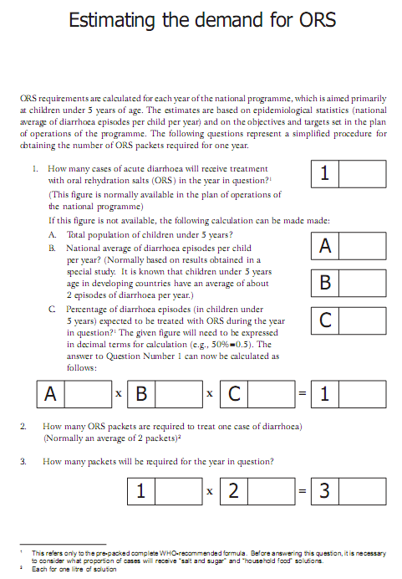

IMPORTANT QUERIES BY PARENT OF THE CHILD
Q. How do I measure the Salt and Sugar?
Different countries and different communities use various methods for measuring the salt and sugar.
- Finger pinch and hand measuring, and the use of local teaspoons can be taught successfully.
- A plastic measuring spoon is available from Teaching Aids at Low Cost (TALC) with proportions to make up 200 ml of sugar/salt solution.
Whatever method is used, people need to be carefully instructed in how to mix and use the solutions.
Do not use too much salt. If the solution has too much salt the child may refuse to drink it. Also, too much salt can, in extreme cases, cause convulsions. Too little salt does no harm but is less effective in preventing dehydration.
A rough guide to the amount of salt is that the solution should taste no saltier than tears.
Q. How much solution do I feed?
Feed after every loose motion.
Adults and large children should drink at least 3 quarts or liters of ORS a day until they are well.
Each Feeding:
- For a child under the age of two
Between a quarter and a half of a large cup
- For older children
Between a half and a whole large cup
For Severe Dehydration:
Drink sips of the ORS (or give the ORS solution to the conscious dehydrated person) every 5 minutes until urination becomes normal. (It's normal to urinate four or five times a day.)
Q. How do I feed the solution?
- Give it slowly, preferably with a teaspoon.
- If the child vomits it, give it again.
The drink should be given from a cup (feeding bottles are difficult to clean properly). Remember to feed sips of the liquid slowly.
Q. What if the child vomits?
If the child vomits, wait for ten minutes and then begin again. Continue to try to feed the drink to the child slowly, small sips at a time.
The body will retain some of the fluids and a salt needed even though there is vomiting.
Q. For how long do I feed the liquids?
Extra liquids should be given until the diarrhoea has stopped. This will usually take between three and five days.
Q. How do I store the ORS solution?
Store the liquid in a cool place. Chilling the ORS may help. If the child still needs ORS after 24 hours, make a fresh solution.
10 Things you should know about Rehydrating a child.
- Wash your hands with soap and water before preparing solution.
- Prepare a solution, in a clean pot, by mixing
- one teaspoon salt and 8 teaspoons sugar
or
- 1 packet of Oral Rehydration Salts (ORS)
- with one litre of clean drinking or boiled water (after cooled)
Stir the mixture till all the contents dissolve.
- Wash your hands and the baby's hands with soap and water before feeding solution.
- Give the sick child as much of the solution as it needs, in small amounts frequently.
- Give child alternately other fluids - such as breast milk and juices.
- Continue to give solids if child is four months or older.
- If the child still needs ORS after 24 hours, make a fresh solution.
- ORS does not stop diarrhoea. It prevents the body from drying up. The diarrhoea will stop by itself.
- If child vomits, wait ten minutes and give it ORS again. Usually vomiting will stop.
- If diarrhoea increases and /or vomiting persists, take child over to a health clinic.
How to use homemade ORS by IAP
Guidelines for use of homemade ORS are:
(i) Give homemade ORS as often as the child will take it. A teaspoon every 1 or 2 minutes is ideal for a child under 2 years. An older child should take sips from a cup as often as he or she can. If the child vomits, wait 10 minutes then give the solution more slowly;
(ii) Give homemade ORS until diarrhea stops;
(iii) Keep homemade ORS covered when it is not being used;
(iv) Through away leftover homemade ORS after 24 hours;
(v) Mix new homemade ORS each day;
(vi) Keep breastfeeding and give your baby or child liquids. Clean water, soup, rice water, yogurt drinks, and homemade ORS solution are good drinks. Continue giving these liquids until the diarrhea stops;
(vii) Get help from a trained health worker if the child does not get better in 3 days or has any of these problems: watery stools, repeated vomiting, eating or drinking poorly, fever, very thirsty, and blood in the stool.
Establish rehydration cells as close to the camps and shelters as possible.

Footnote:
People often refer to home-prepared oral rehydration solutions as "home-brew." This should be discouraged because the word brew implies:
- either fermenting which in fact is an obstacle to some home-prepared solutions especially those made with rice-powder
- or it implies boiling (as in tea) which, especially with sugar and salt or using packets of ORS, should not be done because it decomposes the sugar, or caramelises.
CHLORINATION OF DRINKING WATER

Safe drinking water:
Safety of drinking water can be ensured either at the point of storage or distribution. Various methods practiced are:

1. Boiled water: Water could be boiled for 10 to 15 minutes and then stored in clear and covered containers. This could be used after it has cooled.
2. Use of chlorine tablets: Nascent chlorine makes water safe for drinking:

Wight of tablet | Strength of Chlorine | Quality of water for disinfection
2.5 gm | 300 mg | 225 litres
0.5 gm | 25 mg | 20 litres
0.125 gm | 1.25 mg | 1 litre

3. Bleaching powder: Bleaching powder is used to disinfect usually bigger sources of water. Usual dose (with 35% chlorine) 2 gms for 5 litres of water. If water is in the wells, the quantity of water could be estimated as:

Diameter of well X Depth of water X 5 = gallons of water in well

4. Monitoring: Chlorine content of water is estimated by chlorinometer. At least 0.245 ppm of chlorine should be available in water for safe drinking.

- Microscopical and bacteriological examination including stool culture should also be done at frequent intervals.

Source: www.rajrelief.nic.in/dmdata/.../Annexure-IX%20guidelines.doc

How to prepare chlorine solution for decontamination
Chlorine (Tablets): They are available as Halazone tablets in the market. Dissolve two chlorine tablets in one-litre of water to prepare a0.5 % chlorine solution.
Bleaching powder (Chlorinated Lime): It contains 33% available chlorine. 20 grams of bleaching powder should be dissolved in one-litre of water to prepare a 0.5% chlorine solution. Bleaching powder should be stored in a dark, cool and dry place in a closed container that is resistant to corrosion.
Chlorine Solution: Readymade chlorine solutions of varying strengths are easily available in the market.
Action of Chlorine
When chlorine is added to water there is formation of hydrochloric and hypochlorous acids.
The hypochlorous acid ionises to form hydrogen ions and hypochlorideions.
The disinfecting action of chlorine is mainly due to hypochlorous acids.
Chlorine acts best when the PH of water is 7 because of predominance of
hypochlorous acids.
Steps
1. Immediately after use draw the chlorine solution into the syringe and soak all instruments, syringes and cannula in a plastic bucket containing 0.5%chlorine solution.
2. Rinse your gloved hands in the solution and carefully take off your gloves and soak them also in the chlorine solution.
3. Remove the bowl from the operation theatre and keep at the place where the instruments are to be washed.
4. Let the instruments be soaked for ten minutes before removing for further cleaning and washing. Since chlorine has a corrosive effect on metal, the metal instruments should be removed after ten minutes.
5. While removing the instruments from the solution, the person cleaning
them should wear gloves to avoid contact with skin (Chlorine is an
irritant to the skin).
6. The solution should be changed after two uses. Always make a fresh solution for the third procedure.
Cleaning: After decontamination, the instruments should be washed thoroughly with running tap water or lukewarm water and a detergent(not soap) solution.
Hot water should not be used as it can coagulate the protein in bloodstains and thus make it hard to remove. Detergent is used because proteins and oils will not be removed with water alone. Soap is not used because it can leave a residue, which again is difficult to remove.

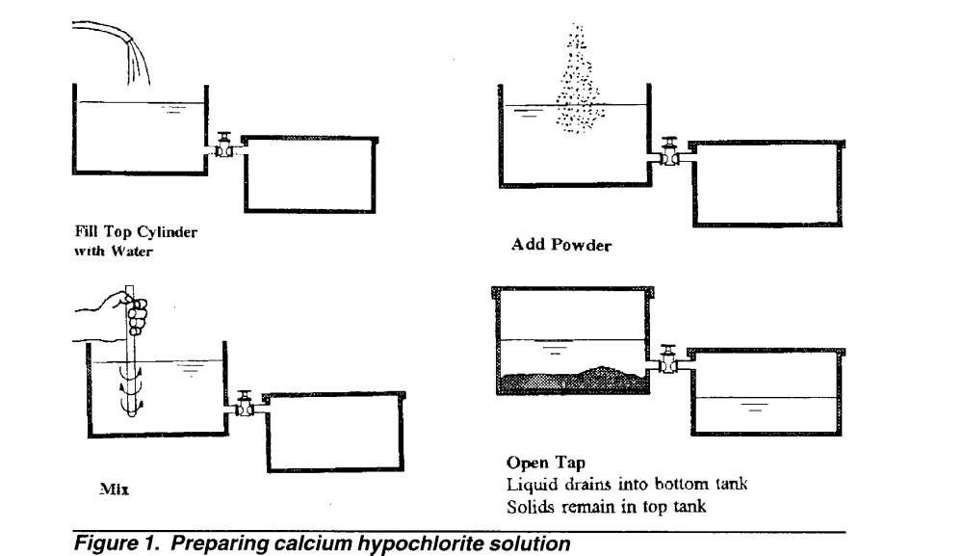

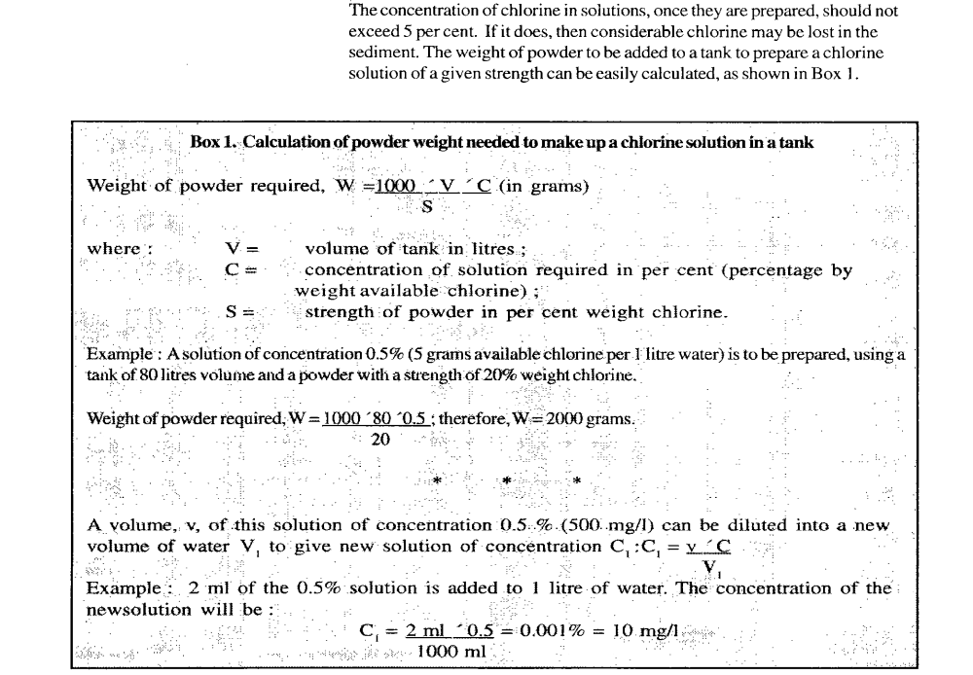

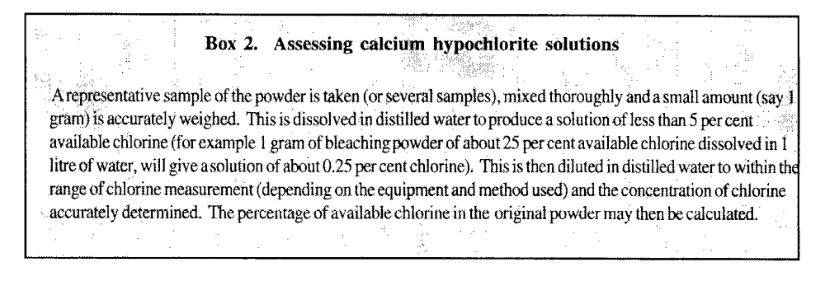
Disinfection
Household water which is contaminated but fairly clear can be disinfected to make it safe to drink. There are various ways of disinfecting household drinking water, such as using iodine, but the most common method is by chlorination. Normally, a one per cent solution of chlorine should be made up using either sodium hypochlorite (liquid bleach), calcium hypochlorite (powdered chlorine) or HTH (high test hypochlorite - a high strength powdered chlorine).
CAUTION Chlorine is a hazardous substance. In solution it is highly corrosive and splashes can cause burns and damage the eyes.
All containers in which chlorine is stored should have a label showing what type of chlorine is in the container and a warning that chlorine is dangerous. Places where chlorine of any type is kept should be locked. Chlorine solutions should be kept in a cool, dark, dry place in closed corrosion-resistant containers such as plastic, ceramic, dark glass or cement.
Household drinking water should not be disinfected with chlorine before filtering, as the disinfectant will be neutralized by the filter.
Disinfection does not work well in turbid or cloudy water, as the chlorine is absorbed by the suspended particles in the water. Chlorine disinfectant is available in several forms as follows:
Sodium hypochlorite or liquid bleach - liquid bleach is normally bought in bottles or sachets. Check that the contents are sodium hypochlorite and water only. The normal concentration of chlorine in household bleach is one per cent, but this may be lower if the bottle or sachet has been opened or stored for a long time.
Calcium hypochlorite and HTH - calcium hypochlorite and HTH are sold as white granules and can often be bought from a local ministry of health office or from commercial warehouses and pharmacies. Calcium hypochlorite is much stronger than liquid bleach and does not lose strength so quickly. Calcium hypochlorite comes in various forms which can have from 20 to 70 per cent chlorine. The best type to use is high test hypochlorite (HTH or HTHC), as this normally contains 50 to 70 per cent chlorine. Always check with the supplier or on the side of the container to be sure of the percentage chlorine content.
Disinfecting household drinking water
When disinfecting household drinking water the one per cent chlorine is added to the water and left for 20 minutes to allow sufficient contact time for the chlorine to work. It is important to use the correct amount of chlorine, as too little will not kill all the germs present and too much may make the water unpalatable and cause consumers to reject the water. As a general rule, three drops of chlorine solution should be added to every litre of water. This can be done using a simple dropper tube or a syringe.
If sodium hypochlorite is used, it can be added directly from the bottle, as it comes with a chlorine concentration of one per cent. If calcium hypochlorite or HTH is used, they will need to be diluted to one per cent before being added to the water. The quantity of powder used will depend on the concentration of chlorine present. Check on the container or with the manufacturer's instructions.
A one per cent chlorine solution can be prepared from chlorine powder in various ways. These are covered in more detail in Fact Sheet 2.19. Strict attention should be paid to the manufacturer's instructions when preparing chlorine solution. Local materials can be adapted to measure chlorine powder or quantities of water to make up chlorine solution. Figure 7 shows an example of this.
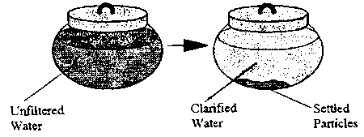
Figure 7. Local method for preparing chlorine solution
When disinfecting water on a household basis, it is important to make sure that easily available local materials can be used to prepare the chlorine solution so that all households can chlorinate their water.
Chlorine demand and residual
When chlorine is added to drinking water, some chlorine is used up immediately by the water. This is the chlorine demand of the water. The chlorine demand of a particular water source does not normally change much over many years.
When chlorine is added to water, there must be enough chlorine to satisfy the demand and also to leave a small amount of chlorine residual to kill the germs left in the water and help prevent re-contamination.
If the water has a high chlorine demand, 3 drops of chlorine solution in every litre of water may not be enough to leave a residual, and more chlorine will need to be added. A simple test to check that there is enough chlorine in the water, is:
? Taste the water. You should be able to taste the chlorine slightly.
? If there is no chlorine taste, add one more drop of chlorine solution for every litre of water in the storage container and leave for 20 minutes.
? Taste the water again. If there is a slight chlorine taste, there is enough chlorine in the water.
? If there is still no chlorine taste, add one more drop of chlorine solution for every litre of water, wait 20 minutes and taste again. Repeat this operation as often as necessary.
Some people do not like the taste of chlorine and will refuse to drink water with chlorine in it. This can mean that these people will then drink from unsafe water supplies. Adding lemon or other fruit juices to the water will help to hide the taste of the chlorine and make the water more acceptable.
Storage
Good storage for the water is probably the most important way of keeping household water clean. It is a waste of time purifying water or collecting water from a clean source and then storing it where it can easily become contaminated. Storage containers therefore need to be well designed and should protect the water from contamination. The two most important factors influencing contamination of water storage containers are whether there is a lid or cover and the means of drawing the water from the container.
Storage containers without a lid or a cover will allow water to become contaminated rapidly because:
? Children or adults with dirty hands can put their fingers in the water and pass germs into it.
? Animals, such as cats or chickens, can drink directly from open containers and so pass on germs.
Storage containers should always have a lid, as shown in Figure 8
Figure 8. Water storage container
When water is taken out of the container there are many ways that pathogens can get into the water, for instance:
? When a dirty cup is dipped into the water container it will pass germs into the water.
? Water should be drawn from the container by a ladle or scoop, as shown in Figure 9. To prevent contamination, this ladle should not be used for any other purpose and should be kept in the water storage container with a small hole cut out in the lid to allow the handle of the ladle to stick out.
? If a ladle is left lying outside the water container flies can land on it and animals or humans with dirty hands can touch it. This will pass on germs to the ladle and so to the water the next time it is used.
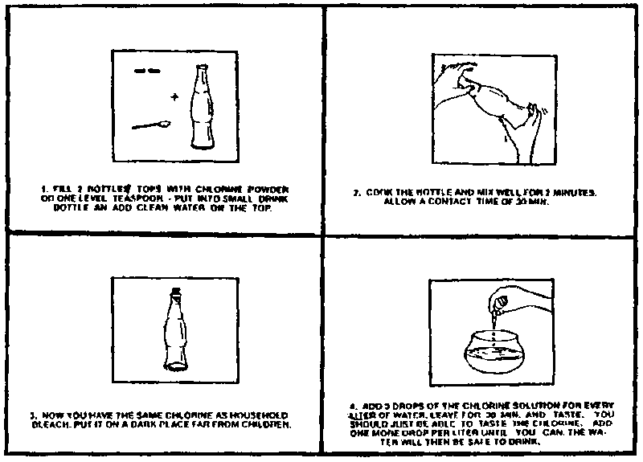
Figure 9. Using a ladle to draw water
Another good way of preventing water in the storage container from getting contaminated is to pour the water from the container into a cup or to make water containers with narrow necks (see Figure 10).
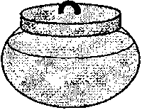
Figure 10. Water container with a narrow neck
This way, fingers or cups never come into contact with the clean water and cannot contaminate it. In some areas, local ceramic water storage containers are made with taps so that water can be drawn from the tap.
In some countries, water is stored on the floor to keep it cool. This makes water more accessible to children and animals, and increases the risk of contamination. Water should be stored above the reach of children or animals. Earthenware jars or pots are good water storage containers, as they allow some water to evaporate thereby keeping the water cool. This does not present any problem of contamination, provided the water is covered and a sanitary means of water withdrawal is used.
Source: http://www.who.int/water_sanitation_health/emergencies/envsanfactsheets/en/index1.html

Sub: Guideline for disinfection of Water sources
Disinfection of Water Sources:
a) Well : Measurement of quantity of water in a well D2 X W X 5 gallons
Where, “D” stands for diameter in foot.
“W” stands for depth of well in foot.
30 gr. of Bleaching Powder/100 gallons of water
or 2.5 gm. of Bleaching Powder/1000 litres of water
(0.7 mg. of applied Chlorine per litre of water)
(Bleaching Powder of good quality should contain 3.3 p.c. of Chlorine)
(1 cft. Of water= 6.25 gallons & 1 gallon of water weighs 10lbs).

b) Very rough and common formula of disinfection of a Tube-well: - 1
Match- box of Bleaching Powder for a Tube-well.

c) Pond-Water-disinfection : 100 gr./per running(instant method) metre
Continuing method (Practical Method): Bleaching Powder depot on two slides
of the bathing ghat for slow and constant release of chlorine enhanced by
movement of water each time.

d) Disinfection of domestic water sorces:
Halazone Tab; One tab of 5 mg. in one litre of water to be used after half hour
i.e. the tab. Having been completely dissolved.

e) Other Sanitation purposes: Bleaching Powder is to be mixed with lime in
the proportion of 1:9 respectively for sanitation purpose.
Source: government of west Bengal,Directorte of health services, Public health branch,Swasthya bhavan, gn 29 sector v,Salt lake, kolkata 700091,Phone (033)23330 180/183-5 fax (033) 2357 7391
Email: idsp.wb@wbhealth.gov.in

Annexure:

SECTION B

ENTOMOLOGY

INSECTICIDE TREATED MOSQUITO BEDNETS

For use with house to house promotion guidelines and for community action

Key messages on Malaria
- Malaria is a dangerous disease caused by infected mosquitoes.
- Malaria is curable and preventable.
- Pregnant women and children under 5 years of age have a greater risk.
- Mosquitoes breed in standing water around the houses; standing water should be cleared to prevent mosquito breeding.
- Mosquito screens or curtains on doors and windows in the house protect and reduce mosquitoes.
- Sleeping under a mosquito bednet will protect against bites and malaria.
- Babies, pregnant women and children under 5 years of age should especially use bednets.
- Repellents and mosquito coils can also help to reduce the risk of mosquito bites.

Key messages on bednets

- Impregnated bednets are treated with an insecticide to kill mosquitoes which come in contact with the bednet.
- Old and new bednets can be treated with an insecticide.
- Insecticide-treated mosquito bednets should not be washed frequently after treatment.
- Bednets need to be retreated with insecticide after 4-6 months.

What you should know and do in your community
- Work with a partner who distributes impregnated bednets.
- Learn what the people know and think about the malaria disease, its prevention, mosquitoes and the use of bednets.
- Know the attitudes and obstacles on use of bednets?
- Explain where bednets are available? What is their cost? Is there local production of bednets?
- Explain where to go to treat bednets with insecticides and who is doing this? What is the cost?
- Explain the dangers of malaria, especially for pregnant women and children under 5 years of age.
- Explain and demonstrate the proper use of bednets.
- Revisit each house to learn about problems they may have with the bednets, respond to questions and monitor correct usage.

How to use a bednet properly
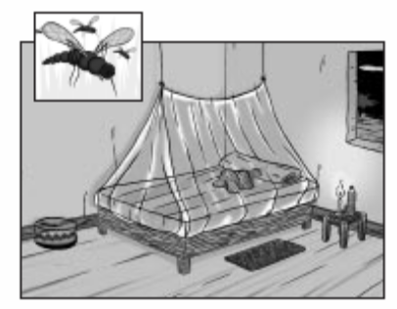
- Make sure the bednet is tucked under the mattress or mat (if sleeping on floor)to prevent mosquitoes from entering.
- Bednets should be washed thoroughly before they are treated with insecticide.
- Once the bednet is treated with insecticide it should not be washed too frequently.

Volunteer’s checklist for promotion of impregnated bednets
- You have all the information necessary on impregnated bednets.
- You know where bednets are available and their cost.
- You know where bednets can be retreated with insecticide.
- You know the attitudes and behaviours of the community members regarding the use of bednets.
Measuring your success
- An increasing number of families are using impregnated bednets.
- More babies, pregnant women and children under 5 years of age are using bednets.
- Families get their bednets retreated each season.
Keeping records and reporting on your volunteer work
[ ] The total number of households under your responsibility.
[ ] The number of households visited this month.
[ ] The number of households which acquired new bednets this month.
[ ] The total number of households with bednets.
[ ] The number of days you volunteered during the month.

Please note - Window and door curtains (nets) can also be treated with insecticide to decrease the mosquito population.

Remember: Whenever visiting a household, you should remind pregnant women about the need for prenatal consultations and tetanus vaccination. Mothers of children under one year of age also need to know about the need for childhood vaccinations. Exclusive breastfeeding of infants through six months of age is also important.

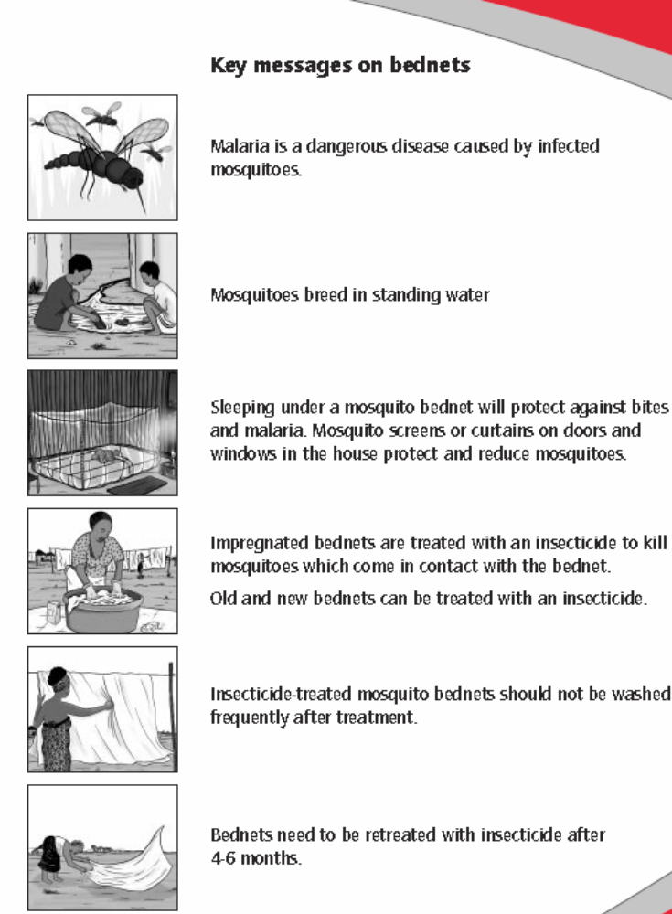

Source ARCHI 2010, A toolkit FOR Volunteers international Federation Of Red Cross and Red Crescent Societies
Treatment and Use of Insecticide-Treated Mosquito Nets

Why use Insecticide-Treated Mosquito Nets?

- Malaria and certain other diseases are transmitted by the bite of mosquitoes. Pregnant women, babies and young children are at the greatest risk of dying of malaria.

- Ordinary untreated mosquito nets provide limited physical barrier between mosquito and man and protection as they may still bite through the net or get inside the net following improper use.

- Mosquito nets treated with insecticides provide better and effective protection by keeping away mosquitoes as well as killing them. An insecticide-treated mosquito net also kills or keeps away other nuisance insects – cockroaches, bedbugs, houseflies, fleas, etc.

How to treat the net – 10 Easy Steps for Mass Treatment

- Mass treatment is done at fixed/designated sites.
- Insecticide treatment is recommended for synthetic nets (nylon, polyester), as treatment of cotton nets is not cost-effective and effect of insecticide is not long lasting.

Step 1: Collect the necessary equipment

The necessary equipment consists of: mosquito nets, insecticide, basin, measuring container, rubber gloves, soap.

- Make sure the net is washed/cleaned before treatment.
- Preferably, nets should be treated outdoors in the shade. If treatment is to be carried out indoors, a room with open windows should be used.
- Use basin, gloves that are not used for any other purpose.

Step 2: Put on protective gloves before treating nets

Step 3: Measure the correct amount of water

The amount of water needed depends on the net material. Regardless of the size and shape of net, the amount of water required for:

- One synthetic net (nylon, polyester) – ½ litre (if the net is very large, more water may be needed).

    - If measuring container comes with insecticide, use it to measure water. Otherwise, use any measuring container, that is not used for food, drinks, medicines.

Step 4: Measure the correct amount of insecticide

- The amount of insecticide or “dose” needed to treat a net depends on type of insecticide used. Follow instructions on the container, sachet, packet. Generally, 10-15 ml of insecticide is required to treat one net.

  - [BIS Number of Liquid Synthetic Pyrethroid used for treatment of Bed Nets -
i) Deltamethrin – IS14411: 1996; ii) Cyfluthrin – IS14156: 1994].
- Store leftover insecticide in its original container, in the dark and away from children.

Step 5: Mix the water and insecticide thoroughly by gloved hands in basin

Step 6: Treatment of nets

- Always treat one net at a time.
- Put the net in the basin containing water and insecticide.
- Soak the net long enough to ensure that all parts of the nets are impregnated.
- Take out the nets and allow excess liquid to drip back.
- Do not wring the treated net.

Step 7: Drying the nets

Let the net dry flat in the shade on plastic sheets.
- Later, the net can be hung up to finish drying in the shade.

Step 8: Disposal of leftover mixture of water and insecticide and insecticide containers

- Following treatment of all available nets, leftover mixture of water and insecticide, if any, may be used to treat curtains.
- Otherwise, dispose the liquid in the toilet or a hole away from habitation, animal shelters, drinking water sources, ponds, rivers, streams.
- Destroy empty insecticide containers, sachets, packets and/or bury in a hole away from habitation, animal shelters, drinking water sources, ponds, rivers, streams.
Step 9: Washing and cleaning of hands, equipments
- Wash equipments (basin, measuring container) with lots of water while wearing protective gloves.
- Wash gloves (if non-disposable ones are used)] with soap and lots of water, or dispose with insecticide containers.
- Wash hands with soap and lots of water.
Step 10: Washing and re-treatment of nets
- Washing removes insecticide from the net. So, wash the nets as seldom as possible and gently with soap and cold water and dry flat on plastic sheet in shade.
- Do not wash/rinse treated net in or near drinking water sources, ponds, lakes, rivers, streams. Dispose of water for washing/rinsing in the toilet or in a hole away from habitation, animal shelters, drinking water sources, ponds, rivers, streams
  - Nets must be re-treated again after it has been washed three times. Or, at least once a year even if it is not washed, preferably just before the rainy season. Nets may be treated twice a year in areas that have a lot of mosquitoes all year long.

Remember:
- Use the insecticide-treated net every night, all year round, even if mosquitoes are not seen/heard.
- Preferably, everyone should sleep under a treated mosquito net. Or, at least pregnant women and children under five years must sleep under treated net.
- Insecticides used for mosquito nets are not harmful to people, if used correctly.
Direct skin contact with the insecticide on a still wet net may cause a tingling sensation on the skin. This is not harmful, even for small children.
- After treatment, the net may smell of insecticide. This will go away in a few days and is not harmful to people who sleep under the net.

Source: ITBN guidelines in nvbdcp/malaria.
Annexure:

GUIDELINES DISTRIBUTION OF INSECTICIDE TREATED BEDNETS (ITBN)

1. Preamble

Sleeping under a bednet reduces the risk of man-vector contact as mosquitoes bite at night and is thus an effective preventive measure. Treating bednets with a suitable insecticide increases their effectiveness as the chemicals repel the mosquitoes and kill those, which come in contact with the treated bednet. If the bednets are used properly and are not washed, their effectiveness lasts for more than six months. Bednets thus need to be treated twice a year for year round use. In most parts of the country, malaria is seasonal and therefore even a single treatment prior to the transmission season will provide adequate protection during the high-risk period. High coverage with the insecticide treated bednets (ITNs) in an area is thus a cost effective vector control measure besides providing individual protection.

In many states especially in the eastern and north eastern parts of the country, which are also at high risk of malaria, bed net use is relatively high. Promotion of the use of bed nets by the community procured through commercial outlets and treatment of the community owned bednets is important so as to significantly improve the coverage of ITNs in areas with high risk of malaria. Organization of camps through public/private/NGO partnerships for the treatment of community owned bednets, is being piloted and should be extended to other districts wherever operationally feasible.

2. Supply of bed nets under NAMP

Limited supply of bednets for use by those in most need and with limited capacity to buy such nets from the commercial outlets is included in the strategies under NAMP. Areas for bednet distribution should be carefully selected and prioritized based on high risk factors such as high API, high proportion of Pf cases, inaccessibility of the villages or operationally difficult area for indoor residual spray. Preparatory work should be done so that the bed nets are optimally utilized, including identification and recording of the eligible families and health educational activities in the community. Involvement of local community representatives, self help groups and NGOs should be encouraged to promote transparency of operations and optimal use by the community.

3. Criteria for the selection of villages/ subcentre areas

The criteria suggested below are for prioritization of village/subcentres for bednet distribution. Higher priority may be accorded to areas where most of the factors given below exist.

- Consistently high API, high proportion of Pf cases, and/or reported deaths
- Inaccessible (cut off during the high transmission season), remote location
- Limited road and public transportation facilities and poor access to facilities for the treatment of severe and complicated cases requiring immediate medical attention
- Areas operationally difficult for indoor residual spray (IRS) because of difficult terrain, exophilic vectors (indoor biters but outdoor resters) and practice of frequent mud plastering of walls
- Socio-economically disadvantaged
- Children of tribal school / ashram school hostels

4. Criteria for selection of beneficiaries

Efforts should be made to ensure high coverage of bed net use in the area selected for distribution. As a general rule all houses should be covered, unless the household already have adequate number of bednets, suitable for treatment with insecticide (cotton and HDPE are not suitable). It must be ensured that bed nets for use by pregnant women and young children within the household are available. In a family of 5 persons, two bed nets should suffice, provided there is enough space for hanging the bed nets (including space outside the house if people sleep outside).

- All houses should be covered
- Pregnant women and young children should sleep under a net
- Special high risk groups can be identified such as children in tribal school hostels

5. Social marketing

State/ district malaria control society should assess the paying capacity of the community and nominal charges of Rs 10 to Rs 50 may be charged. Free distribution may be made to the most needy and those below the poverty line who are unable to pay. Even nominal payment for the bednets is encouraged as it is expected to lead to a sense of ‘ownership’ and it is more likely that the bednets will used for the purpose for which these have been provided.

6. Preparatory activities

It is important that preparatory work is done to ensure optimal use of bednets. The following activities must be completed prior to the distribution of the bednets.

- Survey of the area – number of households, number of persons in each household, number of pregnant women and children under 5 years of age
  - number of bednets in use
  - knowledge, attitude and practices
b. Identification and involvement of community representatives, self help groups, women’s organizations and NGOs
c. Preparation of the list of beneficiaries
d. Advocacy among the community for the regular and proper use of bed nets; for ensuring that pregnant women and young children sleep under a bed net; insecticide treatment of the bed nets and proper care of the bed nets

e. Selection of site(s) and persons for insecticide treatment of the nets. Training of personnel and necessary items required for insecticide treatment should be arranged

7. Insecticide treatment of the bed nets

Ten easy steps are enclosed.

8. Distribution of the nets

a. Organize camps for distribution of insecticide treated bednets
b. Keep records of bednet distribution
c. Make arrangements for distribution to those who were unable to attend the camp(s)

9. Post Distribution Activities

- Periodic visits may be made to check bed net use
- Arrangements for re-impregnation of bed nets annually prior to the high transmission season
- Monitoring of fever cases and confirmed cases of malaria
- Monitoring of vector densities

Exercise :
- Based on above reading prepare checklist to give advice in effective use of insecticide regarding mosquitoes and insects fleas etc.
- Demonstrate the insecticide treatment of the bed nets at domestic level. Also give counseling upon precautions , for best use etc.

SECTION C

BMW management

- Disaggregating and use of color bags
- Example- Waste Management under RNTCP-- Current Practices
- Preparation of bleaching powder solution of different strength
- Case study –Modassa Gujrat
- Counseling

DIAGNOSTIC JOURNEY WASTE MANAGEMENT SYSTEM:
  - Process Flow Chart: A process flow chart of the existing waste system of the hospital was made which indicated the sequence from generation of waste to its final disposal. The decision points in the flow chart (diamond shape symbols) show the points where data has to be collected (Fig I).

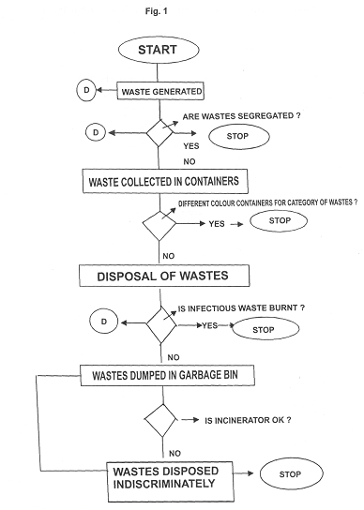

b) Data Collection: Data was collected of the total quantity of waste which showed that
approx. 400 kg. of waste was generated in the hospital per day, out of which only 160 kg. was
bio-medical waste as per the Bio-Medical rules. The Bio-medical waste was not segregated at
source and was mixed and collected in one container in the wards.
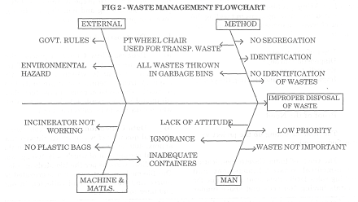

c) In order to identify the root causes, brainstorming for generating ideas was held
amongst the QIP team. About 23 ideas were generated which was further grouped into
Man-related, Method-related, Machine related and External factors. These were depicted in
Ishikawa (Fish bone) diagram (Fig II)

d) Two root causes were identified:
- Lack of awareness of staff about waste management
- No proper process for waste management
e) The root causes were tested through further surveys and Pareto analysis, and were found to
be valid.
Ource: (Juran Inst. 1996)
HEALTH IMPACTS OF BIO-MEDICAL WASTE (BMW)
Sharps may not only cause cuts and punctures but also infect the wounds if they are contaminated with pathogens. Because of this dual risk – of injury and disease transmission – sharps are considered as a veryhazardous waste class.
Poor hospital waste management may cause the following:
• Hepatitis B & C
• HIV infection
• Gastro-enteric infection
• Respiratory infection
• Blood stream infection
• Skin infection
• Radioactive toxicity
• Health problems associated with air and water pollution.

Apart from the above, there are other environmental problems associated with the disposal of untreated BMW generated from the healthcare units (HCUs). These are as follows:
- Decomposing waste may generate foul odour inside the hospital premises and surrounding area.
- Drains may be clogged with waste materials creating an unhygienic environment in the surrounding hospital premises. This phenomenon may also help in the breeding of mosquitoes/flies that might con-tribute to the spread of infectious diseases.
- Waste dump may attract stray animals and birds that might spread waste materials leading to an un-aesthetic and unhygienic environment.
- Indiscriminate disposal of pharmaceutical products (antibiotics and cytotoxic drugs) and discharge of untreated wastewater generated from the health care units could have disastrous ecological effects.
- Open dump of waste may decompose to produce leachate that might contaminate ground water.
- Uncontrolled and open burning of wastes can generate dioxins and furans, thus polluting the air.
CASE STUDY:
Oubreak of Hepatitis B due to improper seggragation at hospitral level or reuse eof syrimges in modasa, gujrat.

Modasa is a city and a municipality in Sabarkantha district in the Indian state of Gujarat. It is an economic centre for agricultural exports, at both the provincial and national levels.

Modasa is emerging as an education centre for the area, with new pharmacy and engineering colleges supplementing the more traditional educational faculties.
An investigation into an outbreak of hepatitis B that claimed at least 57 lives in western India has unearthed an illegal trade in used medical equipment retrieved from hospital waste.
The outbreak in the state of Gujarat has been traced to dirty hypodermic needles that should have been incinerated but instead were simply rinsed, repackaged and resold to private medical clinics, according to police. In the past few days, authorities have seized more than 300 tonnes of neatly sorted medical refuse sitting in warehouses on course for a thriving black market.
The scandal has shone a light into a corner of India’s rapidly expanding health industry, which is attracting growing numbers of foreigners for low-cost treatments. It is believed that the racket involved everybody from cleaners in hospitals who were paid about two rupees per kilogram of raw waste collected, to doctors who ignored safety codes and executives at medical suppliers who set up repackaging plants.
In Ahmadabad, the state capital, investigators found warehouses where used syringes, needles, saline bottles, intravenous drips and vials had been sorted, washed and repackaged for sale, Dr Manish Fenci, a health official, said. At least 20 doctors have been arrested for using or buying the equipment. Two doctors have been charged with culpable homicide.

The alarm was sounded when scores of people fell ill last month in the town of Modasa, the centre of the outbreak. Despite the arrests officials admit that they have no idea of the true scale of the problem and more cases were reported this week. A drive to vaccinate Modasa’s 60,000 inhabitants was begun amid fears that infected equipment is untraceable.
A police spokesman said that many clinics had refused to co-operate. “There is no law calling for them to detail their suppliers,” he said.
It appears that the unsorted waste was taken to several warehouses used by scrap merchants, where women and children would segregate needles and syringes from other medical refuse — itself a hazardous task carrying a high risk of potentially deadly infection. A number of medical equipment suppliers then took the waste and resold it, investigators believe.
Hepatitis B is a disease that can lead to liver damage and cancer. It is spread through infected blood, semen and from contaminated needles. It can be prevented through vaccination.
The economics of the medical equipment industry suggest that the racket had to have been conducted on a huge scale to reap worthwhile profits for the gangs suspected to be behind it. New disposable syringes are available for as little as one rupee (1½p) each.
Since the scandal more than 950 clinics, laboratories and hospitals have been served with notices calling on them to dispose of medical waste properly. Fifteen clinics have been shut permanently after it was found that the staff running them had no medical training.
The scandal is the most shocking example of abuse but unsafe medical practices are rife in Indias. One recent report estimated that India produced 800 million syringes last year, which were used to give 3.7 billion injections, meaning that each syringe was used more than four times on average.
Research published in the Singapore Medical Journal last year found that more than three quarters of medical staff in the Anand region of Gujarat followed unsafe injection practices, including flaming needles for sterilisation, reusing disposable needles and exposure to bodily fluids. The average rate of unsafe injection practice stood at more than 60 per cent.
According to the study more than 80 per cent of government clinics and 70 per cent of private practices still used boiling pans for sterilisation, a practice branded unsafe under World Health Organisation guidelines.

Sources: Hepatitis B kills 57 in lucrative Indian trade in recycled medical wasteTimes Archive, FDA From The Times timesonline.ukMarch 11, 2009

Sources:
- http://timesofindia.indiatimes.com/news/india/Death-factory-in-Bimaru-ujarat/articleshow/4197425.cms

http://www.expressindia.com/latest-news/biomedical-waste-disposal-closure-notice-issued-to-11-odowns/431962/ Wednesday, April 15, 2009 Biomedical Waste Disposal Rules India

- http://timesofindia.indiatimes.com/news/india/Death-factory-in-Bimaru-ujarat/articleshow/4197425.cms

- Suspected Hepatitis B kills 19 in Gujarat Wednesday, February 18, 2009, (Sabarkantha)

IN-HOUSE BMW MANAGEMENT
Segregation of Bio-medical Wastes
As per the Bio-medical Waste (management & Handling) Rules, segregation of BMW should be as
given below:
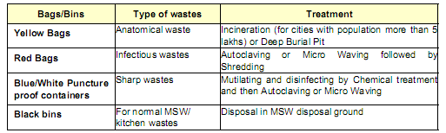
As the entire bio-medical waste has to be either autoclaved or incinerated/buried in deep burial pit,
therefore, keeping in mind the convenience of the waste handler (staff of the health care unit and
facility operator) two nos. colour-coded bags and one no. hard container have been recommended by
the WBPCB:
• Yellow : For Incineration/deep burial
• Blue : For Autoclaving
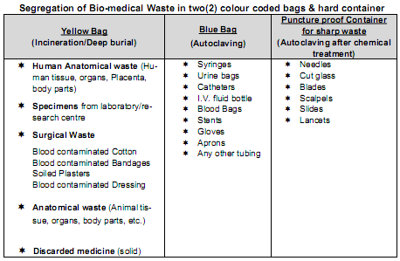
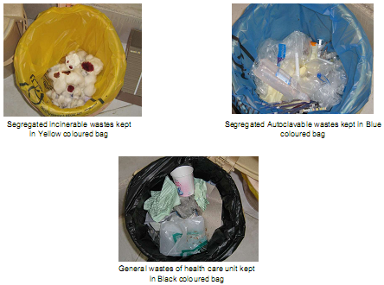

Need For The Segregation of BMW at Source – The Imperative
• If the proper segregation of the waste is not done at source, then the bio-medical waste might get
Mixed up with the municipal waste of the hospital.
• The un-segregated BMW may jeopardize the entire process of the bio-medical waste treatment.
• The un-segregated BMW may endanger human and the animal lives.
• It is vital that all the health care units – both in the Government and in the Private Sector – strictly follow the recommended segregation system for bio-medical waste at source.
• Waste segregation is the key to waste minimization and efficient waste collection, transportation, treatment and disposal.
Bio-Hazard Symbol
It is mandatory for all bags used for storing and transporting BMW to be made of non-chlorinated materialsand bear the ‘Bio-Hazard Sign’
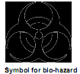
Sharp Waste Management
• The sharp wastes should be handled very carefully
• Before disposing off syringes, these should be mutilated by needle destroyer/cutter.
• In case uncut/ non-mutilated syringes are kept in blue bags, this will result in prick injury, puncture of the bags and spillage of the waste
Mutilation
It is recommended that mutilation should be strictly practiced for disposable needles and other sharp wastes. Mutilated needles and other sharp wastes may be kept in puncture proof containers with 1% Sodium Hypochlorite solution for primary disinfection and the solution should be changed every two days.
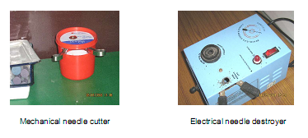

Other important issues of in-house BMW management
- All the disposable items other than waste sharps, like tubings, catheters, saline bottles, I-V fluid bottles etc. shall be punctured before being sent for treatment.
- Waste containing mercury must not be mixed with the other waste streams. The mercury containing wastes shall be kept separately and shall not be disposed along with the bio-medical wastes or general wastes. This waste shall be treated as a hazardous waste and shall be disposed off to the Common Hazardous Waste Treatment, Storage & Disposal Facility
- Responsibility for proper segregation and storage of BMW shall be fixed upon the Nurses & other staff of the health care unit handling BMW. Higher authorities should supervise the management of BMW regularly. Sweepers shall collect the Bio-medical Waste kept in segregated storage in colored plastic bags with mouths securely tied and transfer it to the central intermediate storage room located in a convenient position of the health care unit.
- The intermediate storage room shall be marked with the bio-hazard symbol and kept under lock &key.
- For Laboratory/Clinic – the section in-charge shall be made responsible for supervision & strict implementation in their section.
- For liquid Bio-medical Waste/ leachate (category 8 & 10), the unit shall have to arrange for treatment i.e. chemical disinfection, before discharge to outside drain to meet the prescribed standard.
- A record of BMW generation, treatment and disposal shall be kept & maintained. This shall be made available during inspection by the WBPCB official. Records of BMW management are also required for submission of Annual Return(Form-II) to the WBPCB.
Occupational Safety & Health Provisions for Bio-medical Waste Management
• The BMW should not be touched with bare hands
• Always use good quality gloves, masks, shoes, apron etc. while handling BMW wastes
• The damaged or contaminated Personal Protective Equipment (PPE) must be replaced periodically
• Never recap used syringes, most needle pricks injuries are incidental to recapping
• Wash hands with soaps after handling of wastes
• Immunizations for Tetanus and Hepatitis-B may be administered to certain high risk workers handling bio-medical wastes
• Keep the common intermediate storage room for BMW neat and clean and sanitize it regularly
• Do not keep municipal wastes along with biomedical waste in the Common intermediate storage room.
• Ensure proper monitoring of the waste segregation process, use of appropriate colour coded bags for collection of wastes and storage at common storage room in order to control infection.

Source: bmw report ,HEALTH CARE WASTE MANAGEMENT SCENARIO IN WEST BENGAL

Counseling of the infection control in a community

Food and Water Hygiene
General principles of prevention of food and water borne disease are:
“Cook it, peel it, or leave it”
drink only treated or bottled water;
- eat only hot, recently cooked, well cooked food and fruit you have peeled yourself;
- avoid: ice, ice-cream, salads, raw vegetables, reheated food, shellfish, raw fish, and unpasteurised dairy products;
- be obsessive about washing and drying your hands before touching food; and
- clean your teeth and wash up dishes in treated water

To treat water
- Boil rapidly for at least 5-10 minutes (this kills most viruses & bacteria but it may take longer to kill Giardia, a common parasite contaminating water) or
- Use 2% iodine (available from chemists). Add 4 drops per litre (1 drop per cup) and stand for 30 minutes or
- Use iodine purification tablets (available from camping stores). Chlorine based tablets are less effective.

Treatment of Gastroenteritis
Fluid replacement is the most important part of treating vomiting and diarrhoea

General treatment:
Most travellers' diarrhoea lasts 24-48 hours.
- You should drink lots of clear fluids (no alcohol)
- Drink treated water, juice, or lemonade (diluted 1:4), or rehydration solution (use Gastrolyte, or make your own: 4 teaspoons sugar and 1/2 teaspoon salt per litre of boiled water).
- Antidiarrhoeal medication such as Imodium will relieve the diarrhoea but not treat the infection, so it should not be used if you have high fever or blood in the motions.
- If you are becoming dehydrated, very ill, have a fever, have blood in the diarrhoea, or if you are not improving, get medical help.
Source: www.HealthandCounselingCentre.com,food articles

List of BMW forms in a health facility

SCHEDULE IV
(see Rule 6)

LABEL FOR TRANSPORT OF BIO-MEDICAL WASTE CONTAINERS/BAGS
Day ............ Month ..............
Year ...........
Date of generation ...................

Waste category No ........
Waste class
Waste description

Sender's Name & Address Receiver's Name & Address
Phone No ........ Phone No ..............
Telex No .... Telex No ..............
Fax No ............... Fax No..............
Contact Person ........ Contact Person.........
In case of emergency please contact
Name & Address :

Phone No.
Note :
Label shall be non-washable and prominently visible.

FORM II
(see rule 10)

ANNUALREPORT
(To be submitted to the prescribed authority by 31 January every year).
1 . Particulars of the applicant:
(i) Name of the authorised person (occupier/operator):
(ii) Name of the institution:
Address
Tel. No
Telex No.
Fax No.
2. Categories of waste generated and quantity on a monthly average basis:
3. Brief details of the treatment facility:
In case of off-site facility:
(i) Name of the operator
(ii) Name and address of the facility:
Tel. No., Telex No., Fax No.
4. Category-wise quantity of waste treated:
5. Mode of treatment with details:
6. Any other information:
7. Certified that the above report is for the period from
Date ........................signature .............................

Place........................Designation.............................

FORM III
(see Rule 12)

ACCIDENT REPORTING
1. Date and time of accident:
2. Sequence of events leading to accident
3. The waste involved in accident :
4. Assessment of the effects of the accidents on human health and the environment,.
5. Emergency measures taken
6. Steps taken to alleviate the effects of accidents
7. Steps taken to prevent the recurrence of such an accident

Date ............... Signature .......................

Place...............Designation......................

OCCUPATIONAL HEALTH
Triage
The concept of triage is simply a method of quickly identifying victims who have immediately life-threatening injuries AND who have the best chance of surviving so that when additional rescuers arrive on scene, they are directed first to those patients.
Golden hour
The Golden hour refers to a concept that a trauma patient has the best chance for recovery if he or she can get to Advanced Trauma Life Support within one hour from the time of the injury. Obviously, those who are most seriously injured have the least time. When there are multiple victims, the Golden Hour can slip away because there aren’t enough rescuers for each victim.
START (Simple Triage and Rapid Treatment)
The START triage system, developed by Hoag Hospital and the Newport Beach Fire Department (Newport Beach, CA), relies on making a rapid assessment (taking less than a minute) of every patient, determining which of four categories patients should be in, and visibly identifying the categories for rescuers who will treat the patients.
_____ VIDEO _____
If you are the initial START rescuer, you DO NOT stop to do other than the most basic intervention. If you attempt to treat every patient before completing the triage, you cannot assess the rest of the patients and identify the top priorities.
Remember that in a serious disaster, it is unlikely that you can save all the victims. The important thing is to work together with the other rescuers to save as many patients as you can. START gives you the best chance of doing that.
The START flowchart is a quick way to learn the system. As you move through the patient assessment, sequentially evaluate the current status for RESPIRATIONS, PERFUSION, and MENTAL STATUS (RPM). You either assign the victim a classification or you move to the next level of the flowchart.
There are two flowcharts presented. The first shows the details of going through the START assessment. The second is a simplified flowchart. Use whichever one makes the most sense to you.

Simplified Flowchart
START Triage
Assess, Treat, (use bystanders)
When you have a color
STOP - TAG - MOVE ON
M  I  N  O  R | -- Move Walking Wounded
M  I  N  O  R | D  E  C  E  A  S  E  D | -- No RESPIRATIONS after head tilt
M  I  N  O  R | D  E  C  E  A  S  E  D | I  M  M  E  D  I  A  T  E | -- Breathing but UNCONSCIOUS
M  I  N  O  R | D  E  C  E  A  S  E  D | I  M  M  E  D  I  A  T  E | -- Respirations - over 30
M  I  N  O  R | D  E  C  E  A  S  E  D | I  M  M  E  D  I  A  T  E | -- Perfusion Capillary refill > 2  or NO RADIAL PULSE  Control bleeding
M  I  N  O  R | D  E  C  E  A  S  E  D | I  M  M  E  D  I  A  T  E | -- Mental Status Unable to follow simple commands
M  I  N  O  R | D  E  C  E  A  S  E  D | I  M  M  E  D  I  A  T  E | D  E  L  A  Y  E  D | -- Otherwise
REMEMBER:
Respirations - 30
Perfusion - 2
Mental Status - Can Do

Detailed Flowchart
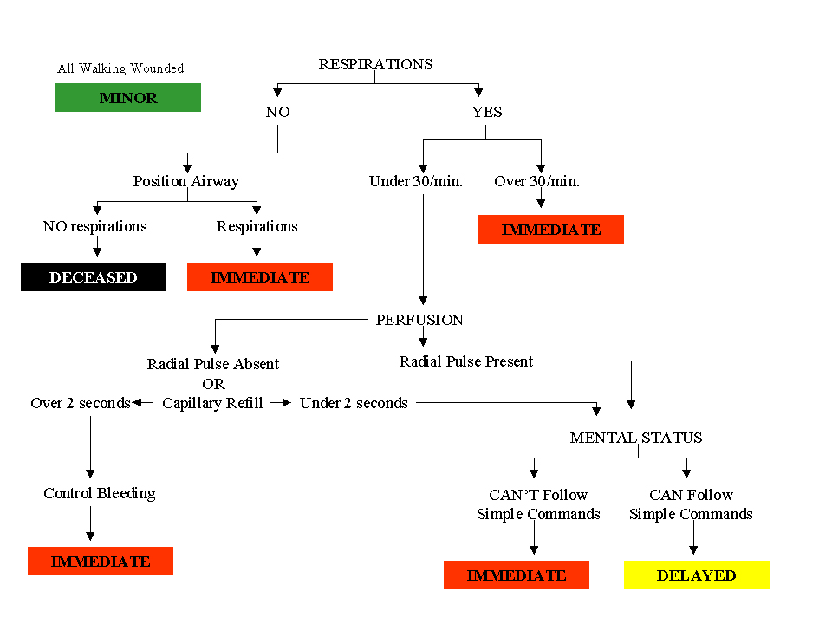

THE TRIAGE TAG --

The triage designation is based on a color system. You place a triage tag on each victim and tear off the colors until the color at the bottom matches the victim’s classification.

The person doing the initial START triage does NOT fill out the tag. Rather, he/she only tears off the color-strip and attaches the tag to the patient. We suggest that that person also write the time and initial the tag.

The actual filling-in-the-blanks of the tag happens either in the treatment area, or in the ambulance, by the 2nd stage personnel.

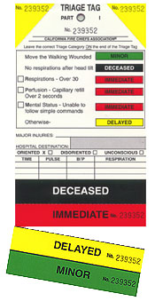 | Black – deceased  Red – immediate  Yellow – delayed  Green – minor  This tag shows the patient's category as "Immediate."

THE TRIAGE TAG --
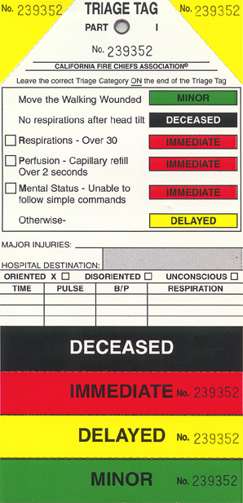 |  | 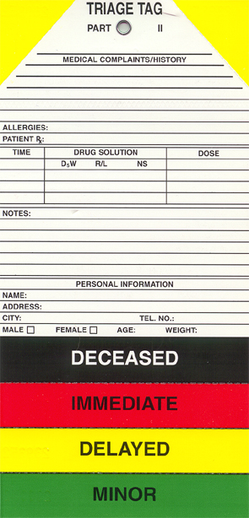

Managing the Scene --
Managing a scene with multiple patients can be frustrating and difficult. These steps will help you systematically triage and treat each patient. They also will give you information to help you determine the number and types of additional rescue personnel, equipment and transport vehicles you need to manage the crisis.
It is important to recognize that you are not abandoning patients by assigning them the Delayed or Minor categories. They are being directed to the rescuers or facilities that have been assigned to handle those patients. The rescuers who are managing the Minor and Delayed patients will be reassessing them and will re-assign them to the Immediate category if they deteriorate.
_____ VIDEO _____
Immediate - Red
When you arrive at an emergency where someone has used the START triage system, your first priority is to find and treat the IMMEDIATE patients. These patients are at risk for early death - usually due to shock or a severe head injury. They should be stabilized and transported as soon as possible
_____ VIDEO _____
Delayed - Yellow
Patients who have been categorized as DELAYED are still injured and these injuries may be serious. They were placed in the DELAYED category because their respirations were under 30 per minute, capillary refill was under 2 seconds and they could follow simple commands. But they could deteriorate. They should be reassessed when possible and those with the most serious injuries or any who have deteriorated should be top priorities for transport. Also, there may be vast differences between the conditions of these patients. Consider, for example, the difference between a patient with a broken leg and one with multiple internal injuries who is compensating initially. The second patient will need much more frequent re-assessment.
Minor - Green
Patients with MINOR injuries are still patients. Some of them may be frightened and in pain. Reassure them as much as you can that they will get help and transport as soon as the more severely injured patients have been transported. Any of these patients also could deteriorate if they had more serious injuries than originally suspected. They should be reassessed when possible.
Deceased - Black
Check with your local protocols about whether patients marked DECEASED should be moved. Some systems don't want patients moved until a coroner is on scene, unless they are interfering with rescue attempts.
The mnemonic RPM will help you categorize each patient.

Managing the Scene (2 of 2) --
Remember this simple formula to guide your START assessment. RPM stands for
RESPIRATION
PERFUSION
MENTAL STATUS
Sequentially use this assessment system for every patient.
Entering the scene
As always, make sure the scene is safe for you to enter. If it is not, wait until it has be made safe.
Next, ask those who are not injured or who have only minor injuries to identify themselves. Tag those with minor injuries as MINOR.
Minor injuries . . . . . . . . . . . . . . . . . . . . . . . . . . . . . . . TAG MINOR
Ask several uninjured victims to stay close to assist you, direct the others to a designated spot away from the immediate scene to wait for additional personnel.
Respiration
First, determine if the patient is breathing. If yes, immediately check the respiration rate.
_____ VIDEO _____
[START triage rescuer quickly checks respirations to determine if they are too fast.]
If not, reposition the patient. If the patient does not start breathing spontaneously, DO NOT start CPR.
Patient not breathing after repositioning . . . . . . . TAG DECEASED
Move on to the next victim.
(Not starting CPR may be the hardest thing you must do at a multiple casualty scene. But if you perform CPR on one patient, many others may die.)
C-spine injury
You will have to position the airway without manually stabilizing the cervical spine. This is counter to what you have been taught and may result in worsening a cervical spine injury. But if you don’t reposition the victim immediately, the person will die in the field. You won’t have the personnel to carefully stabilize the C-spine and you can’t afford to let other victims die while you take time to do it yourself.
If the patient begins breathing spontaneously after repositioning, tag the person IMMEDIATE and move on. If necessary, ask an uninjured victim to help maintain the open-airway position.
Patient begins breathing after repositioning . . TAG IMMEDIATE
If the victim is breathing when you approach, but has a respiratory rate of more than 30, tag IMMEDIATE and move on. Don’t take time to formally count the respirations. If the rate seems too fast, tag the victim IMMEDIATE and move on.
Respiratory rate >30 . . . . . . . . . . . . . . . . . . . . . TAG IMMEDIATE
Perfusion
If you can feel a radial pulse, move on to the Mental Status assessment.
_____ VIDEO _____
If you can’t feel it, tag the patient IMMEDIATE, have an uninjured victim put direct pressure on any visible, serious bleeding and move on to the next patient.
No radial pulse . . . . . . . . . . . . . . . . . . . . . . . . . TAG IMMEDIATE
Next check for capillary refill. If capillary refill is more than 2 seconds, tag the patient IMMEDIATE, have an uninjured victim put direct pressure on any visible, serious bleeding and move on to the next patient.
Capillary refill > 2 seconds . . . . . . . . . . . . . . . . TAG IMMEDIATE
If capillary refill is less than 2 seconds, move to MENTAL STATUS.
Mental Status
If the victim is unconscious or can’t follow simple commands, tag them IMMEDIATE and move on to the next victim. _____ VIDEO _____
Unconscious, can't follow commands . . . . . . . . TAG IMMEDIATE
If the victim can follow simple commands, tag them DELAYED and move on to the next victim.
Can follow simple commands . . . . . . . . . . . . . . . . . TAG DELAYED

Triage Assessment Exercise --
Assume that all walking wounded have moved away from the area
and that the findings are AFTER you have repositioned
the airway of any non-breathing patients
Victim | Type of Injury | Pertinent Information | Category | Rapid Treatment Needed and Reason
#1 | Compound fracture, left femur | Respirations over 30/minute  Radial pulse absent  Awake | Deceased Immediate Delayed Minor | 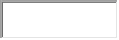
#2 | Sudden onset of chest pain with shortness of breath | Respirations under 30/minute  Capillary Refill under 2 seconds  Awake | Deceased Immediate Delayed Minor | 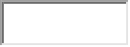
#3 | 90% Second Degree Burns | Respirations None  Radial Pulse Present  Unconscious | Deceased Immediate Delayed Minor
#4 | Facial Injury | Respirations over 30/minute  Capillary refill under 2 seconds  Awake | Deceased Immediate Delayed Minor
#5 | Unable to move legs | Respirations < 30/min.  Radial pulse present  Awake | Deceased Immediate Delayed Minor
#6 | No apparent injuries | Respirations normal  Capillary refill < 2 seconds  Awake | Deceased Immediate Delayed Minor
#7 | Sucking chest wound | Respirations > 30/min.  Radial pulse present  Unconscious | Deceased Immediate Delayed Minor
#8 | Dislocated right shoulder | Respirations < 30/min.  Radial pulse present  Awake | Deceased Immediate Delayed Minor
#9 | No visible wounds | Respirations none  Radial pulse absent  Unconscious | Deceased Immediate Delayed Minor
#10 | Scalp wound, estimated blood loss 500 cc | Respirations > 30/min.  Capillary refill < 2 seconds  Awake | Deceased Immediate Delayed Minor
#11 | Massive head injury | Respirations < 30/min.  Radial pulse absent  Unconscious | Deceased Immediate Delayed Minor
#12 | Bruising over abdomen, complaining of abdominal pain | Respirations > 30/min.  Capillary refill < 2 seconds  Awake | Deceased Immediate Delayed Minor
#13 | Impaled, 1 foot piece of shrapnel in right eye | Respirations < 30/min.  Radial pulse present  Awake | Deceased Immediate Delayed Minor
#14 | Female six months pregnant; broken left, lower leg | Respirations < 30/min.  Capillary refill < 2 seconds  Awake | Deceased Immediate Delayed Minor
#15 | Severe difficulty breathing, chest sinks in on inspiration | Respirations > 30/min.  Radial pulse present  Awake | Deceased Immediate Delayed Minor
#16 | Unable to move, no verbal response | Respirations < 30/min.  Radial pulse present  Awake and staring | Deceased Immediate Delayed Minor
#17 | Amputated left arm, bleeding controlled | Respirations < 30/min.  Capillary refill < 2 seconds  Awake | Deceased Immediate Delayed Minor
#18 | Large head wound, brain matter showing | Respirations absent  Radial absent  Unconscious | Deceased Immediate Delayed Minor
#19 | Minor abrasions | Respirations < 30/min.  Capillary refill < 2 seconds  Awake | Deceased Immediate Delayed Minor
#20 | Bruise on forehead, blood in ears and nose | Respirations < 30/min.  Radial pulse present  Unconscious | Deceased Immediate Delayed Minor
#21 | Third degree burns over front of both legs | Respirations < 30/min.  Capillary refill < 2 seconds  Awake | Deceased Immediate Delayed Minor
#22 | Compound fracture, left arm | Respirations < 30/min.  Radial pulse present  Awake | Deceased Immediate Delayed Minor
#23 | Impaled stick in right chest | Respirations < 30/min.  Capillary refill < 2 seconds  Awake | Deceased Immediate Delayed Minor
#24 | Second degree burns, legs | Respirations > 30/min.  Radial pulse present  Awake | Deceased Immediate Delayed Minor
#25 | Blood in right eye | Respirations < 30/min.  Capillary refill < 2 seconds  Awake | Deceased Immediate Delayed Minor
#26 | Three-month old infant, no visible injury | Respirations absent  Radial pulse absent  Unconscious | Deceased Immediate Delayed Minor
#27 | Impaled object, RUQ abdomen; difficulty breathing | Respirations > 30/min.  Radial pulse present  Awake | Deceased Immediate Delayed Minor
#28 | Patient saying same words over and over, "what happened? | Respirations < 30/min.  Capillary refill < 2 seconds  Awake | Deceased Immediate Delayed Minor
#29 | Spurting blood from neck injury | Respirations > 30/min.  Radial pulse present  Awake | Deceased Immediate Delayed Minor
#30 | Patient states she is a diabetic; skin, moist and clammy; feels shaky | Respirations < 30/min.  Capillary refill > 2 seconds  Awake | Deceased Immediate Delayed Minor

Glossary --
Central Treatment Area: | In the setting of Multi-Casualty Incident, immediate and delayed patients who are awaiting transport, should be moved to a centralized treatment area. This results in a more efficient use of medical supplies and personnel.
Delayed: | Second priority in patient treatment. These patients require aid, but injuries are less severe. These patients may have a wide range of injuries. They should receive more thorough secondary assessment when in a treatment area.
Incident Command System: | A flexible organizational structure which provides a basic expandable system for handling patients from a multi-casualty incident.
Immediate: | A patient who requires rapid assessment and medical intervention for survival.
Minor: | These patients’ injuries require rudimentary first-aid and FREQUENT reassessment.
S.T.A.R.T. | Acronym for “Simple Triage and Rapid Treatment.” This is the initial triage system that has been adopted by F.I.R.E.S.C.O.P.E.’s Multi-Casualty Branch of the Incident Command System.
Standard of Care: | Level of treatment to be rendered to patients.
Triage Tag: | A tag use by Triage personnel to identify and document the patient’s medical condition and treatment.

exercise : http://www.miamidade.gov/oem/CERT/cert-triageQuiz.swf

PUBLIC HEALTH NUTRITION

Activity 1
A case study of Tamil Nadu’s Integrated Nutrition Programme
It was a state programme started with world aid bank. It occurred in two phases and subsequently second phase merged with Integrated Child Development Services scheme. It provides many lessons in conducting Nutrition programme. The programme was designed to include the component most likely to have impact on the nutritional status.

Objectives:
- Improve nutrition and health status of pre school children, pregnant and nursing mother.
- Reduction in prevalence of severe and moderate protein energy malnutrition in pre school children.
- Reduction in infant mortality rate.
- Reduction in vitamin A deficiency.
- Increase immunization coverage.

Community Need Centers were established in villages of 1500 population, with a Community Nutrition Worker (CNW) in charge of the centers. CNW was a local woman who was received an initial practical training of two month and continued to have in service training for two days every month.

Beneficiaries are:
- Malnourished children
- Pregnant and nursing mother and those who had 4th or higher parity
- Pregnant and nursing mother having edema or those having twin Pregnancy.
Services provided:
- Monthly growth monitoring
- Short term supplementary feeding to malnourished children
- Iron folic acid tablets are given to mother for 3 months. Counseling was done for home care of feeding and management of diarrhea
- All children under three were de-wormed and 2, 00,000 i.u. of vitamin A was given twice a year.
- Feeding was given to children with grade III and IV degree of malnutrition.
- Grade I and II and normal children were given supplementary feeds if found losing weight.

- Define the problem.
- Critical analysis of the problem
- Possible reasons for the problem
- Collection of facts and figures
- Alternative solutions to the problem
- Selection of best alternative solution with the reasons
- Action plan with remedial measures

Questions
- Compare the functioning of Tamil Nadu’s Integrated Nutrition Programme with the services provided under ICDS scheme?
- Using the guidelines in the above programme and the ICDS scheme, Prepare a framework for simple interventional programme for the pediatrics population in your feed practices area.

Activity 2
Rapid Community Based Assessment of Situation at Khalwa Block, Khandwa District, Madhya Pradesh
Khalwa block is situated in Khandwa district of Madhya Pradesh and has a population of 1, 59, 897. There was a report of a number of child deaths from Mojvadi (population 1500) and Gadbeli (population 1300) villages of the block, following which a team of specialists visited the affected areas. Both the villages are dominated by the “Korku” tribe who mainly practice “Dhadki (daily wages)”. The average monthly income of the families is around Rs 1500 per month and they reside in mud houses. On visits to the houses it was observed that there was overcrowding in all the houses with poor ventilation. The source of drinking water in the villages was handpump with unsanitary conditions in the cone of filtration leading to contamination of water, moreover the storage of drinking water in the houses visited was found to be unhygienic. Infant and Young Child Feeding practices were poor in the area and Exclusive Breast feeding was seldom continued for 6 months. As regards the behaviuor in health and disease local practices like “Chachwa (burning of skin of abdomen)” in case of fast breathing were prevalent. Though both the villages had functional Anganwadi Centers and Mojvadi also had Sub Health Center traditional healers “Padiyaar (Tantriks)” were consulted for ailments. The nearest Community Care Center was located in Khalwa which was situated at about 8 kms from Mojvadi and 6 km from Garbedi. During the visit a total of 32 children from 0-5 years were examined. The age and sex distribution of the children are as follows:

Table 1: Distribution of Children According to Age
Age (months) | Number | Percentage
0-12 | 12 | 37.5%
13-24 | 6 | 18.75%
25-36 | 10 | 31.25%
37-48 | 2 | 6.25%
49-60 | 2 | 6.25%

Table 1: Distribution of Children According to Sex
Sex | Number | Percentage
Male | 19 | 59.4%
Female | 13 | 40.6%

Out of the 32 children 20 were found to be malnourished. The Grade wise distribution of malnourished children is as follows:
Grade | Number | Percentage
I | 5 | 25%
II | 7 | 35%
III | 7 | 35%
IV | 1 | 5%

The Anganwadi Workers of the village reported that in spite of their best efforts the people were not at all receptive to the services provided and the workers also complained of inadequate supplies to the centers which further complicated the problem. There were similar reports of eight deaths from Saidabad and Mohalkheri village of Khalwa block of Khandwa district due to malnutrition.

- Define the problem.
- Critical analysis of the problem
- Possible reasons for the problem
- Collection of facts and figures
- Alternative solutions to the problem
- Selection of best alternative solution with the reasons
- Action plan with remedial measures

Questions:
- Enlist the plausible reasons for prevailing malnutrition and possible deaths due to it despite availability of functional Government health services in the area.
- Chalk out an interventional plan to combat malnutrition in the area with emphasis on the social determinants of the problem.
- Represent the data in suitable diagrams and charts?

Activity 3
- Discuss a policy agenda related to nutrition for your district.
………………………………………………………………………………………………………………………………………………………………………………………………
- After studying the National Nutrition Policy, identify points that are of importance to your field area.
………………………………………………………………………………………………………………………………………………………………………………………………
- Formulate your comments on these policy points, are they desirable and implementable, what role can members of District Health Management Team have in the implementation of the Nutrition policy.
………………………………………………………………………………………………………………………………………………………………………………………………

Assessing iron status on the basis of resource availability in a country

Level of  resources | Poor | Intermediate | Adequate
Prevalence  of anaemia | Severe | Moderate | Mild
Clinical decisions
Screening | Clinical examinationb | Haemoglobin  or haematocrit for screening | Haemoglobin or haematocrit  for screening  Additional testsc:  Serum ferritin  Transferrin saturation
Confirmation  or diagnostic or | Haemoglobin or haematocrit Clinical response to  iron administration | Haemoglobin or haematocrit response to  iron administration | Haemoglobin or haematocrit response to iron administration  to iron Serum ferritin  administration Erythrocyte  protoporphyrine  Transferrin saturation  Transferrin receptor
Public health and population-based decisions
Special  assessment  or survey | Haemoglobin or haematocrit | Haemoglobin or haematocrit Optional:  Mean cell volume Serum ferritin Transferrin  saturation  Erythrocyte  protoporphyrined d | Haemoglobin or haematocrit Mean cell volume  Serum ferritin  Transferrin saturation  Erythrocyte protoporphyrine Transferrin receptor
Diagnosis of causes  of anaemia | Response to iron supplement e,f
Long-term  surveillanc | Haemoglobin or haematocrit from PHC or MCH centres | Haemoglobin or haematocrit from PHC or MCH centres at selected sites | Haemoglobin or haematocrit from clinics

Footnotes to Table 5 (opposite)
a Relative terms that correspond approximately to the level of development according to UN Classification (United Nations Development Programme. Human Development Report. New York, Oxford University Press, 1999).

b Severe prevalence of anaemia (> 40%) justifies universal iron supplementation without screening individuals. The clinical assessment of anaemia lacks sensitivity and, therefore, a prevalence of 2%-3% of cases clinically detected represents severe problem.

c Serum ferritin or transferrin saturation in addition to haemoglobin or haematocritis of interest in individuals for detecting mild forms of iron deficiency or iron overload.

d Specific iron biochemistry tests may lose some sensitivity in populations that also have high rates of infections.

e Anaemia response to treatment for malaria or hookworm should be considered in areas with a known incidence of these conditions.

f Where nutritional deficiencies, such as of folic acid, vitamin C, or vitamin A, are believed to contribute to anaemia, multiple supplementation should be considered.

g Consistent use of the same procedures, (e.g. compilation of data from clinics, even if inadequate for statistical assessment) may nevertheless reveal trends useful for population surveillance.

Prevention strategies
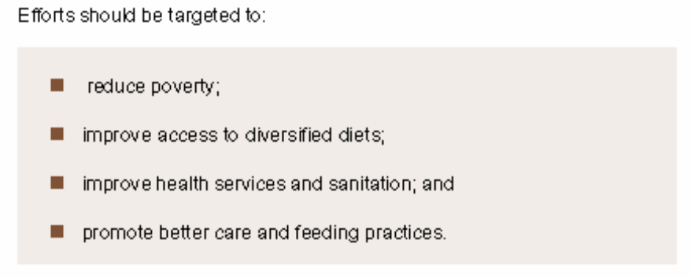
8.1 Food-based approaches
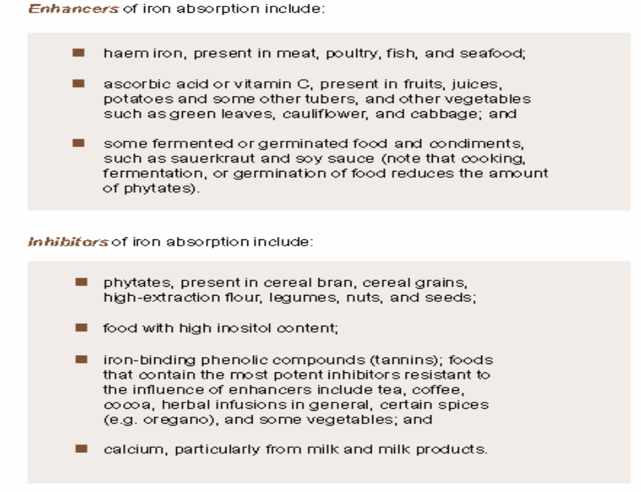
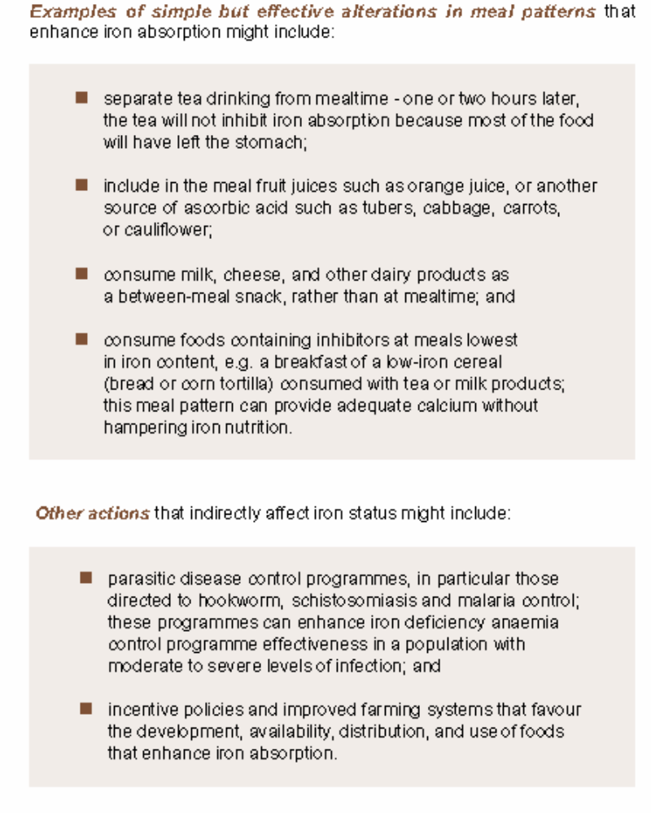
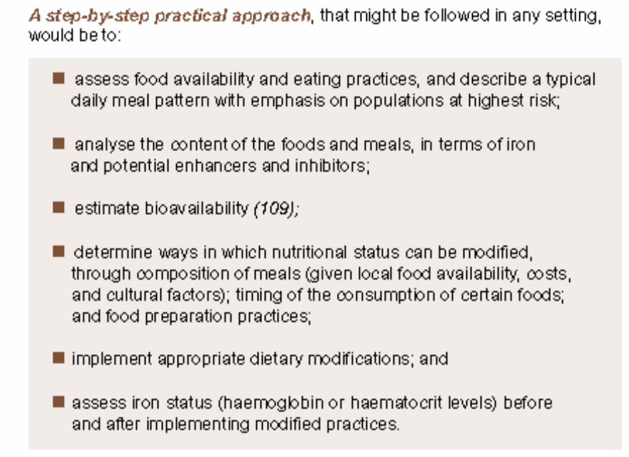
8.1.2 Food fortification

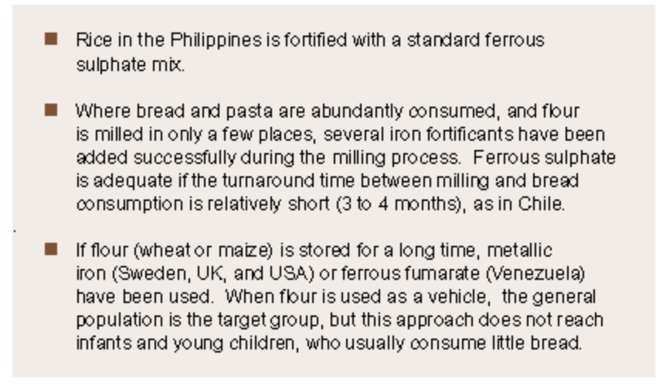

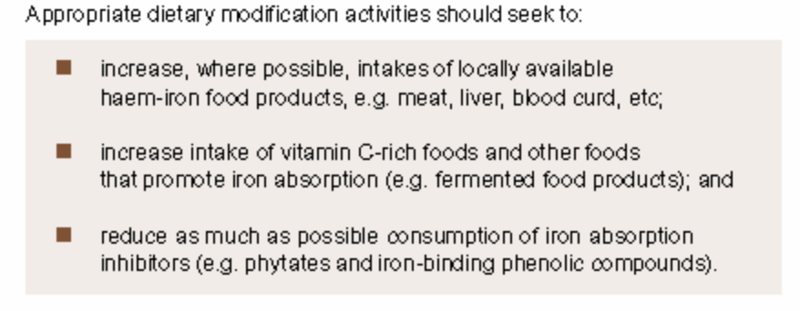
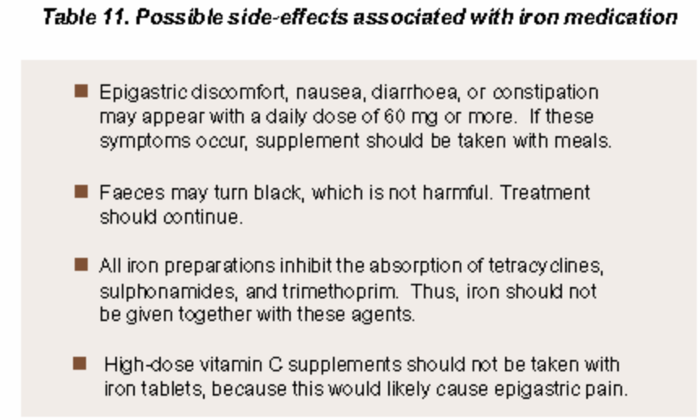

Diet planning
The following children also need special attention:
- Twins or underweight babies.
- Children who are not breast-fed.
- Children whose parents are often away for various reasons.
- Children whose weight does not increase within three months.
- Children in families where previous children have died in the first two years of life.
- Children who suffer from infection or illness frequently.
- Children who are born less than two years apart.
- Children whose parents have a history of chronic diseases or are addicted to alcohol and drugs
Malnutrition
Malnutrition in a child is the result of the lack of quality food.
The following are the characteristics of Malnutrition:
- Hair becomes rough, less shiny, and may fall out.
- Skin becomes rough, dry and thick, especially on the feet and lower portions of the hand.
- Eyes become dry, lustreless and colourless. This often happens with Vitamin A deficiency.
- Corners of the lips develop small pimples or bristles, swelling and cracks.
- The tongue loses its sense of taste. It turns pink and develops cracks.
- Teeth become weak and brittle. They may also turn brownish or off-white.
- The entire body frame starts to decay. As a result, wrists become broad and bones become soft and brittle.
Protein energy malnutrition (PEM):
Visible mostly in infants and kids, PEM develops due to a deficiency of energy giving components, particularly carbohydrate and protein, in foods.
Early detection of malnutrition is important. In appearance, the child might look normal but its weight would be less than what it should have been. In such cases the child's skin may become loose, thighs and upper arms look especially bony. The child's stomach may also stick out.
Marasmus:
This is the most prevalent disease among children in the age group of 1-6 years.
Symptoms:
- Child becomes extremely thin
- Face wrinkles and looks older; his/her face resembles that of a monkey
- Rough and dry hair
- Enlarged eyes
- Always hungry
Treatment:
Intake of foods, which give instant energy, mostly fruits and vegetables, which are full of fibre, like bananas, carrots, radishes, turnips etc.
Children should be fed thrice a day and, if necessary, they should also be given light food between meals at short intervals.
Kwashiorkor:
This disease has no age bar but is most likely to occur to children between 1 ½-4 years.
Who is more prone to it?
Mostly those children who are breast-feeding and very rarely take other food. It affects children who are compelled to leave breast-feeding due to the birth of another child. The main cause of this disease is protein deficiency.
Symptoms:
- Rough and dry skin
- Swelling on face, wrist, arms, legs and feet
- Child loses its appetite
- Dry, reddish hair and skin
Treatment:
The child should be given protein rich food such as vegetables, milk, eggs, baked peanuts, grams, bananas, mangos etc. The child should be given food at short intervals.
Xerophthalmia:
Xerophthalmia is often caused by Vitamin A and protein deficiency. It is mostly prevalent in children between the ages of 1 and 3. The prevalence of this disease is often connected with weaning the child from breast milk. Affected children often come from poor families. Apart from this, lack of knowledge about nutrition, wrong ways of breast-feeding, continuous diarrhoea and measles may also cause this disease. Continuous deficiency of Vitamin A causes blood spots in the eyes. Sometimes loose-motions coincide with measles and make the cornea thinner, which, in turn could lead to blindness.
Prevention:
- Intake of Vitamin A pills. First dose of Vitamin A should be given to the child along with a measles vaccine
- After every six months, doses of Vitamin A need to be given to the child. This should continue till the child is 3 years old 3. Fruits and vegetables should be included in the child's diet.

Health and Development of Baby
The baby should have a diet, which is substantial as well as rich in food value. Following is a chart indicating the resources of various elements necessary for growth and development.
Cereals and Pulses:
- Carbohydrate - Wheat, rice, maize, jowar, ragi, pulses.
- Protein - Pulses, nuts.
- Fat - Oil seeds, nuts.
- Vitamin and minerals - Rice, wheat, ragi, bajra, maize, pulses.
Vegetables and fruits:
- Carbohydrate - Banana, plantain, breadfruit, potatoes, sweet potatoes, tapioca.
- Protein - Peas, beans, soybeans, groundnuts, dark green leafy vegetables.
- Vitamin and minerals - Spinach, drumstick leaves, amaranth carrots, tomatoes, yellow pumpkin, papaya, amla, orange, mango, lemon.
Animal Products and other Resources
- Carbohydrate - Milk and milk products, meat, sugar canes and sugar.
- Protein - Milk and milk products, eggs, meat, fish.
- Fat - Oil, milk, cheese, butter, ghee, eggs, meat.
- Vitamin and minerals - Milk and milk products, meat, eggs.

The Elements of a Healthy Diet
Nutritious food gives our body the energy and substances to ...
Food is made up of specific nutrients - proteins, carbohydrates, fats, vitamins, minerals and water - all of which are necessary for life, growth, body function and tissue repair.
Any one food may contain several of these essential nutrients, together with the substances needed to assist their absorption. These essential nutrients can be broken into two main groups
- Macronutrients, which include fats, carbohydrates and protein. They produce energy and are required in quantities easily measurable by a common scale.
- Micronutrients, which include vitamins and minerals. They are essential for helping our bodies work properly and strengthening our immune system so that we can resist infections. They are only required in very small or "microscopic" amounts.
To get the most nutrition from your food, you should remember:
- Eat fresh foods with the minimum of processing.
- Eat raw fruits and vegetables whenever possible. If you do cook them, use as little water as possible because many nutrients are destroyed by heat or boiled out of the food into the water.
- Eat fruits and vegetables with skins (apart from carrots, which can absorb toxins from the soil). Wash them carefully first.
- Don't cut, wash or soak fruits and vegetables until you are ready to eat them.
Planning Balanced Meals
To get a healthy diet we need to eat many different types of food each day including fruit and vegetables, grains, roots, beans, pulses, nuts and animal products. It is not healthy to eat the same food with the same ingredients every day.
The amount we eat depends on our age, sex and time of life. However, the most important aspect of healthy eating is balance.
Healthy food is fresh and natural and a balanced diet should be full of flavour and colour. By taking care to choose foods that are in season and locally available, eating can be enjoyable, healthy and affordable.

Preparing Balanced Meals
Processing
Fermenting
Cereal flour can be mixed with water and left for two-three days. Fermenting cereals allow more iron, zinc and calcium to be absorbed.
Germinating
Seeds can be soaked in water for one day and than covered with a damp cloth for two days. The sprouted seeds can be dried and than milled to make germinated flour. This type of flour does not thicken much during cooking, so less water needs to be used. Germinated flours allow more iron, zinc and calcium to be absorbed. If a little of this flour is added to warm thick porridge [view consistency of porridge], it makes it soft and easy to eat.
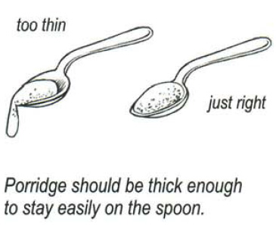

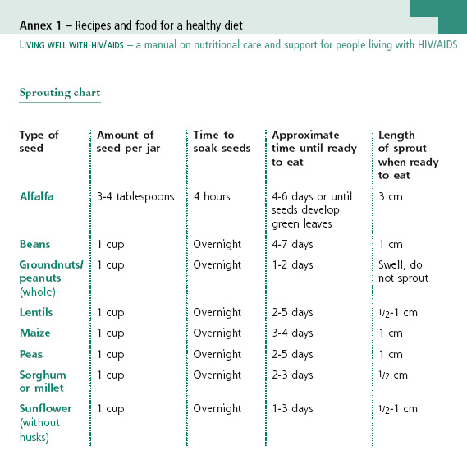
Preparing Balanced Meals
Preparing
Hygiene in the kitchen
Keep all food preparation surfaces clean. Use clean dishes and utensils to store, prepare, serve and eat food.
Use a different knife and chopping board for raw meat and fish and another for other foods. Wooden chopping boards are more germ-resistant than plastic ones. Always ensure that chopping boards are washed carefully after each use.
Use safe clean water from protected sources to wash fruit and vegetables. If the water is not from a protected source, it should be boiled for ten minutes or filtered.
Keep rubbish in a covered bin and empty regularly.
Clean the refrigerator regularly with a diluted bleach solution and mop up any spills immediately.
Personal hygiene
Wash your hands, preferably with soap and water before handling the food and cover all wounds to prevent contamination of food during preparation and handling.
Avoid sneezing or coughing on food or scratching your skin when cooking.
Food preparation
The way we cook our food is very important. If we follow simple, careful methods we can get the most from our food, On the other hand, if we overcook our food or blend it or use baking soda we will destroy most of the goodness in the food. Easily available, delicious traditional ingredients can be made simply into tasty healthy food.
When cooking, try to avoid:
- Undercooking, especially meat, eggs and beans
- Overcooking, especially vegetables
- Adding too much salt, sugar or spices
- Leaving food to get cold before eating it
- Reheating food that has been cooked before
Remember that vitamins and minerals are damaged when:
- Left in the sun or heat, air or water
- Mixed with baking powder
- Food is cut up into small pieces or blended
- Food is reheated or left standing after cooking
- You drink tea / coffee with food as this interferes with iron absorption in the body
Vegetables
Eating raw fruit and vegetables means that you get more vitamins and minerals and you save fuel. Raw vegetables such as carrots, cucumber and tomatoes or raw fruits make excellent snacks between meals. Raw vegetables can be served as salads with meals. Herbs such as parsley, mint, lemon grass, fennel and dill and sliced spices such as ginger and garlic may be added to salads.
Wash salads carefully but never soak vegetables for long periods as you may loose all the water-soluble vitamins such as B and C.
Cooking leafy green vegetables
When cooking leafy vegetables, tear the leaves into pieces rather than cutting them with a knife. This preserves their vitamin C content.
Do not use bicarbonate of soda when cooking green vegetables, as this destroys vitamins.
If you do cook vegetables, use a small amount of water to steam the food rather than boiling it. If you boil the food, add the drained water to stews and sauces.
The healthiest way of cooking spinach is by steaming the leaves on a sieve over rapidly boiling water so that the steam cooks the leaves. Keep stirring the leaves with a wooden spoon so that they all become exposed to the steam. The spinach should be cooked in about five minutes.
Try stir-frying vegetables for a few minutes in a little oil as this helps to absorb fat-soluble vitamins like A, D, E and K.
The less time you cook vegetables, the more nutrients you will preserve.
Note: Cabbage does not contain as many vitamins and minerals as other dark green vegetables. It requires a lot of fertilisers and pesticides to grow and takes up a lot of space in gardens. Cabbage leaves should not be picked until the vegetable is mature, when the whole plant is harvested.
For more info, check: Boiling time for different types of vegetables
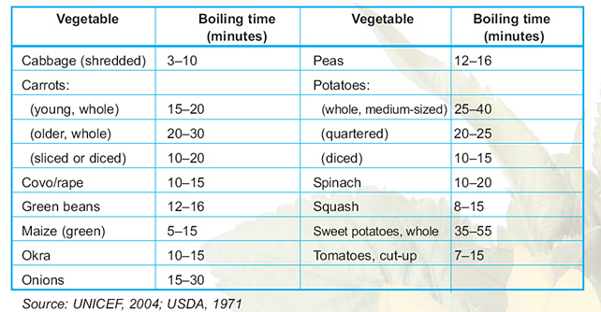

Cooking beans
Many different types of beans are grown and eaten including sugar beans, cow peas, pigeon peas, soya beans and dried groundnuts.
Beans can cause gas and bloating. They take a long time to cook and use a lot of fuel to cook.
Best ways of cooking beans include:
- Soaking beans overnight before cooking to reduce gas and cooking time
- Skimming off the foam produced by the beans during cooking to prevent gas and bloating This can be done with a spoon
- Using a pressure cooker or a hot box cooker [ making a hot box cooker ] to save fuel and the time you spend watching the food cook
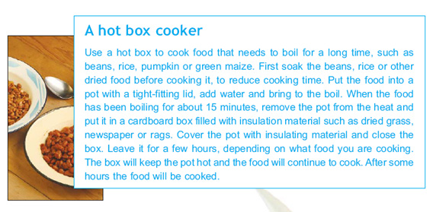
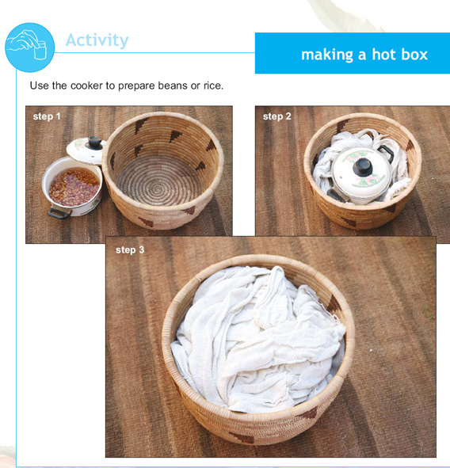
Cooking meat, poultry and fish
It is advisable to cut off the fat from all types of meat as fat is a notorious store for chemicals and pesticides.
Do not serve anything with raw or lightly cooked eggs to children, elderly and anyone with an impaired immune system because of the risk of salmonella.
Poultry and meat should always be cooked through to avoid risk of food poisoning. Barbecued food can be unhealthy. Food tends to char on the outside and remain undercooked on the inside, which can cause food poisoning.
Stuffing should be cooked outside the poultry because bacteria from the raw meat may survive when it is cooked inside.
Fish is best grilled lightly so that it becomes tender but not raw. Fresh sea-foods should be steamed gently in as little water as possible until they are thoroughly cooked

SALT TESTING
Fortifield Common Salt for Prevention of Deficiency Disorders

Product/Process: Common salt fortified with iodine or/ and iron.

Application/Uses: To improve micronutrients status of population to prevent deficiency disorders due to iodine or / and iron. The fortified salt can also be used for cattle.

Salient Technical Features: Iodine and iron deficiencies are widely present in the country. The micronutrients can be conveniently delivered through common salt.
NIN has developed a simple and inexpensive technology to fortify common salt
With iodine or/and iron:
(i) Powdering of crystal salt to uniform size in a crusher
(ii) Mixing powdered salt with iodine or/and iron chemicals in the right proportion
Along with appropriate stabilizers for nutrient retention, in a blender for a specified
Time
(iii) Packaging of the fortified salt.
Dry mixing technology and uniform distribution of the micro-nutrients are the salient features of the present technology. Single Fortified Salt (SFS) technology is in production state. Approximately Rs.3 lakh investment is sufficient for producing 2000 kg/day.

Scale of Development: The technology is at the level of pilot scale.

Status of Commercialization: Technology has been transferred to Ankur
Chemfood Products (Guj.) Ltd., Gandhidham.

SALT TESTING KIT
Rapid testing kits for iodine/ iron in edible salt
To estimate quickly iodine/iron content of fortified salt under field conditions
Salt is fortified with micro-nutrients such as iodine and iron. It is often necessary to know their contents to ensure that the consumer gets the quality product. This can be assured if a rapid test method is available for use under field conditions. Very few such rapid test kits are available in the market.
The present kit consists of (i) two reagent solutions (one for iodine and one for iron) in a 10 ml capacity plastic dropper bottle, and (ii) standard colour gradation charts for iodine (0,7,15,and 30 ppm) and iron (0,500,850, and 1000 ppm). To a pinch of salt placed in a white background, a drop of the reagent solution is added and the colour produced is at once compared with the colour gradation card. The required values at the consumer level are > 15 ppm iodine and > 850 ppm iron. One reagent bottle lasts for 100-200 tests. The testing can be done by any person
Appropriate chemical reagents
NA
Not commercialised
This is a domestic level technology and the minimum economic unit may vary; total investment may not exceed a few thousand rupees
Explain the outline of the technology to entrepreneurs and demonstration
Available at NIN Highly acceptable among manufacturers, users and NGOs advocating the use of fortified salt
Very good potential in view of easy availability of fortified salt
No
No
No
nil
Director, National Institute of Nutrition Jamia-Osmania PO, Hyderabad 500 007, Andhra Pradesh
Dr. S. Ranganathan, Senior Medical Physicist and Radiological Safety Officer, National Institute of Nutrition, Jamia-Osmania PO, Hyderabad 500 007, Andhra Pradesh. Phone:040-7008921; Fax-.Q40-7019074;
Email:drrangan@rediffmail.com

GUIDELINES FOR CONDUCTING HEALTH AND NUTRITION DAY

Why VHND
• The Villagers will be able to interact with health personals.
• Will learn preventive and promotive aspects of healthcare
• Obtain basic services and information.
• As the venue is generally Anganwadi Center/ Village a site very close to the village, villagers will not have to spent money or time on travel.

Day of organizing VHND : 2nd, 3rd, 4th Wednesday and 3rd Saturday.
Venue : At AWC, If AWC is not available in a village; VHSC will fix the venue of the VHND
Who will organize : ASHA along with members of the VHSC.
Who is responsible for monitoring: District Media Expert, with the help of Block Monitoring team and District Community Mobilizer from ASHA Resource Center.
Staff to be present at VHND : ANM/ LHV/ AWW/ ASHA/ ASHA Facilitator/ Health Educator/ BEE/ M.O. /PRI Members/NGO Members.
Action to be taken by ASHA
One week Before VHND
• Visit all household of the village including SC and ST family
• Make a list of pregnant women who need to come for ANC
• Make a list of infants who need immunization or leftout or dropout
• Make a list of children who need care for malnutrition
• Make a list of eligible couples who are not using any FP methods.
• Make a list suspected TB cases/ Malaria/ Diarrhea etc.
• Invite school teachers/opinion leaders/mother-in-laws/ Adolescent girls and boys to attend the session.
On the Day
• Ensure that all children / pregnant women and others as listed come for services.
Action to be taken by AWW
• Ensure that AWC is clean/ clean drinking water available/ Privacy at AWC for ANC.
• Coordinate activities with ASHA and ANM.

Action to be taken by ANM
• Ensure that VHND is held without fail/ required vaccines reaches the site on time / all
instruments, drugs, other materials are in place.
• Carry IEC materials/ Immunization card/ Counterfoils of the previous sessions./UIP Master
Register and MCH Master Register
• Ensure reporting of VHND in the prescribed format.

Action to be taken by VHSC
• Ensure that Members of VHSC are available to support the session.
• VHSC will provide all equipments viz., BP instruments with stethoscope/ feotoscope/
weighing machines (Baby and Adult/ examination table etc.
• If AWC is not available in a particular village, VHSC will fix the venue of the VHND

Health Education Package
• Health and Sanitation
Personal Hygiene / Social Hygiene / Household Sanitation / Safe drinking Water/ Education
of Children

• Maternal Health:
Micro Birth Planning / JSY Scheme / Need of ANC and PNC / Danger signs during
pregnancy / Importance of institutional delivery and place of Delivery

• Child Health
Exclusive breastfeeding and complementary feeding / Identification of LBW and management
/ Essential newborn care / Routine Immunization / Nutrition / Care during diarrhea and
Pneumonia

• Family Planning
Age at Marriage / Need of family planning / Need of male participation (NSV)

• Communicable and Non-Communicable diseases
Prevention of Malaria and its management / TB and Leprosy / Prevention of HIV AIDS

Service Package
Maternal Health
• Early registration of pregnancy (for confirmation Nischay Kit is to be used). Filling of MCH Card, JSY Card in duplicate. One copy is to be handed over to the pregnant women and another copy to the ANM to make arrangement for incentive under Mamoni scheme during 1stANC.
• ANC to identify high risk pregnancy and complication of pregnancy during Ante Natal period
and timely referral.
• Counseling on danger signs during pregnancy/ Micro Birth planning/ importance of nutrition/ institutional delivery/ Identification of referral transport/ Incentive of JSY/ PNC/ Breast feeding/ Contraception.
• For Adolescent girls counseling on age at marriage/ need of education.
• Group Discussions- If maternal death occurred during the previous month in that village group discussion is to be carried out to identify and analysed possible casuses and how to take preventive measures.

Newborn and Child Health
• Counseling for care of newborn/ feeding/ need of full immunization
• Immunization as needed/ tracking of dropout infants/ giving vitamin A (9 doses)- 1st dose 1ml along with measles vaccine.
• Identification of LBW infants by weighing and nutritional care with the help of AWW.
• Provision of supplementary food for children suffering from malnutrition.
• Providing IFA small tablet to children with clinical anemia.
• Case management of those suffering from diarrhea and pnemonia.
• Organizing ORS depot.
• Counseling on Nutrition supplementation and balance diet.

Family Planning
• Information and distribution of condom/ Oral pills/ E-pills after counseling
• Motivation for Permanent Sterilization of eligible couples having more than 2 children.
• Information on compensation for acceptors.
– LS and other Tubectomy - Rs. 600.00
– NSV - Rs. 1100.00
– IUD - Rs. 20.00
For the motivator
– LS and Tubectomy - Rs. 150.00
– NSV - Rs. 200.00
– IUD - Nil

Sanitation
- Group Discussion on personal hygiene, social hygiene, need of sanitary latrine and disposal of solid and liquid waste.
- Identification of household for construction of sanitary latrines. Guidance on where to go for availing subsidy for those eligibles (BPL) under total sanitation campaign (TSC) by PHED.
- VHSC will provide subsidy for construction of household latrine @ Rs. 300.00 per household for 10 BPL families.

Communicable diseases
• Group Discussion for raising awareness
- in the community regarding elimination of breeding sites for mosquitos. Management of fever cases/ Importance of Blood examination for MP. Use of Impregnated Bed net (IPBN).
- Early sign of Leprosy (Pale or red anesthetic patches in the skin).
- Awareness generation about symptoms of TB (coughing for more than two weeks), importance of continued treatment, referral of symptomatics for sputum examination at the nearest health centre (DOT Center).
- Awareness generation regarding safe drinking water to prevent water borne diseases viz., gastroenteritis, Children diarrhea, dysenteries, Cholera, Typhoid fever, Jaundice, Poliomyelitis etc.

Supervision and Monitoring
- SDM&HO, i/c Block PHC with the help of Block monitoring team will monitor VHND and will take remedial measures to improve the quality of the VHND and will also orient VHSC regarding their responsibility to organise VHND monthly at their villages by providing logistics and other support.
- District Media Expert will be responsible to monitor VHND using BPMU and Asstt. Block Programme Managers.
- District Community Mobilizer from ASHA Resource Center will also monitor.

Reporting
Reporting format of VHND enclosed. Each ASHA after completion of VHND will submit the
filled up format signed by ANM, AWW and herself to the Asstt. Block Programme Manager/ Block
programme Manager on the next Day.

Source: Revised guidelines for conducting Health and Nutrition Day NRHM/ASHA/120/Pt A/06-07/3486-87 dated 16th August 2006, OFFICE OF THE MISSION DIRECTOR NATIONAL RURAL HEALTH MISSION

IYFP
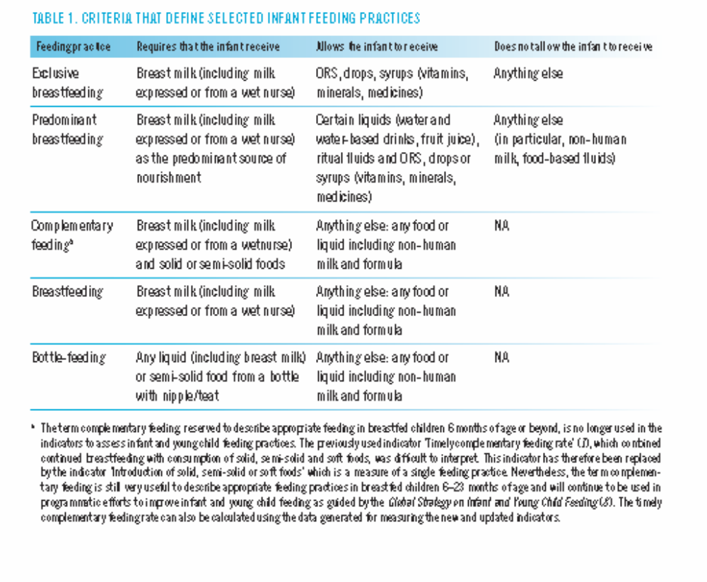

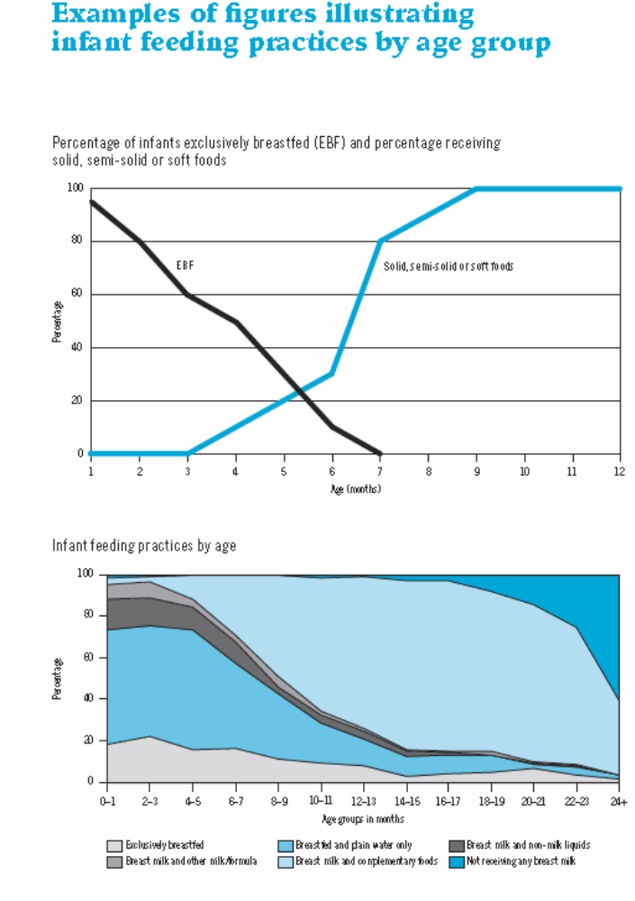
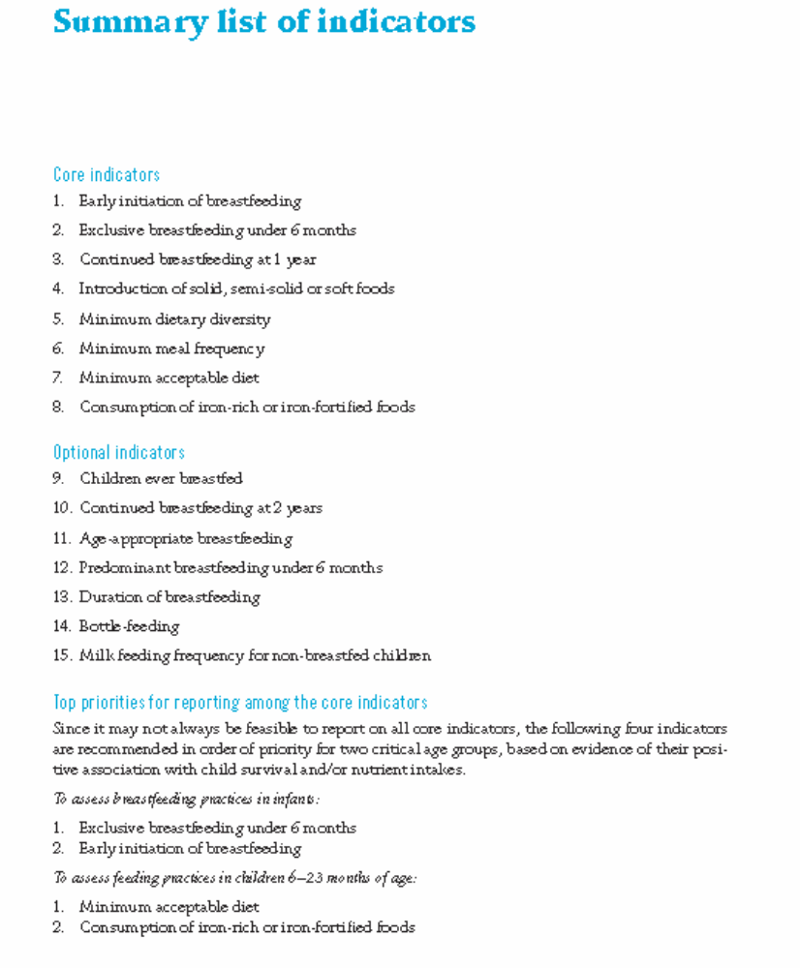

Source: Indicators forassessing infantand young childfeeding practices Part 1

